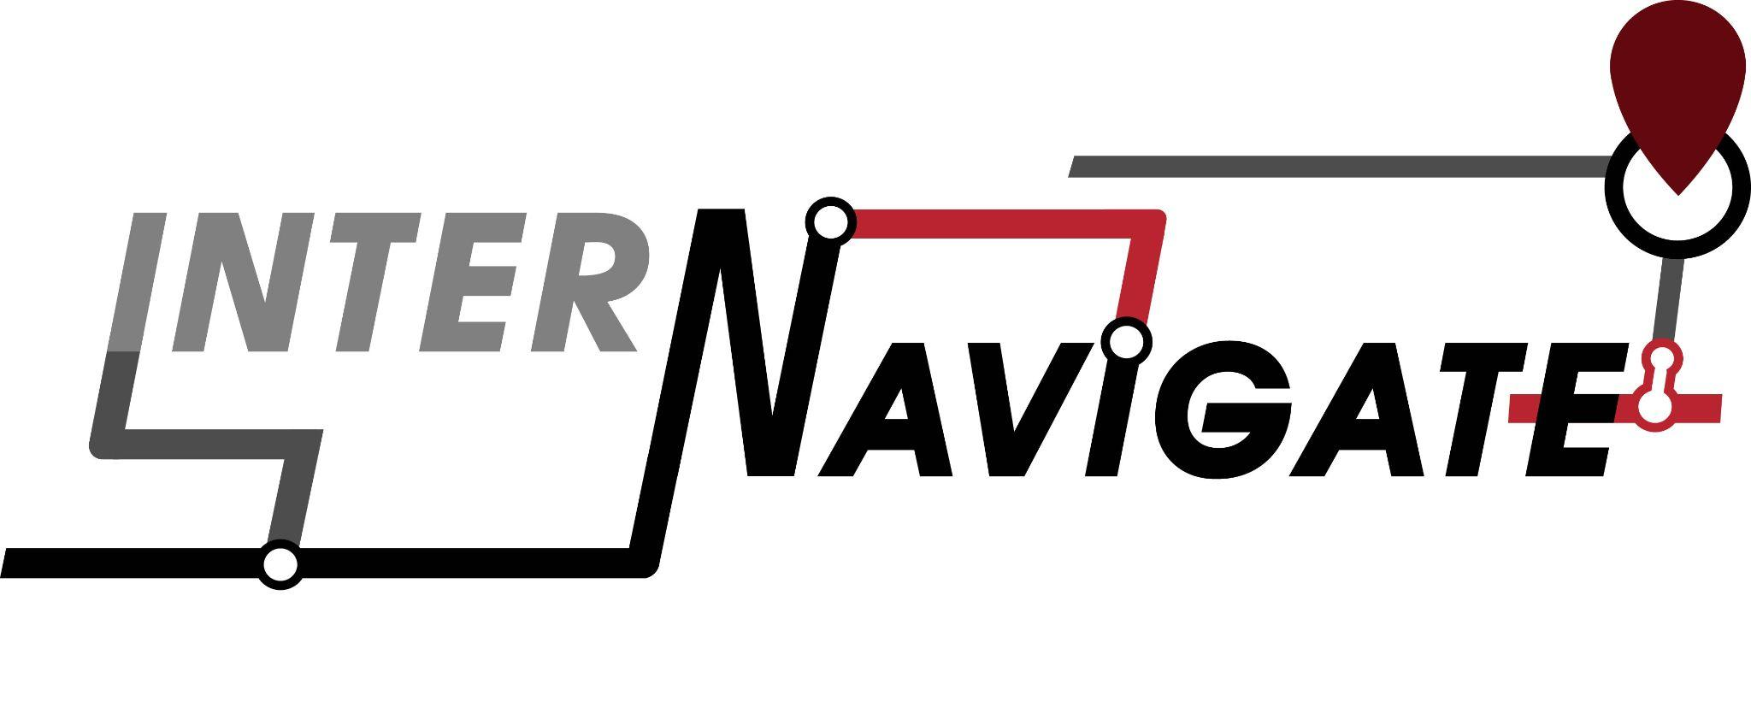

# Streamlining the IDT Graduate Internship Search



## Table of Contents

**Streamlining the IDT Graduate Internship Search 1**

Table of Contents 2

Needs Analysis 3

Introduction 3

Problem Statement 3

Instructional Goal 4

Learner Analysis 4

Context Analysis 5

Constraints 6

Task Analysis 6

Instructional Design Plan 8

Instructional Design Theory and Model 8

M. David Merrill's First Principles of Instruction 8

Curvilinear Depiction of Instruction Design 10

Instructional (Learning) Objectives 11

Instructional Strategies - Design Blueprints 11

Course Information 12

Lesson Topics, Format, and Assessment Template 12

Module 1: Exploring Career Paths (25 minutes) 12

Module 2: Planning for an Internship Search (25 minutes) 14

Module 3: Networking and Professional Communication (30 minutes) 16

Module 4: Designing Internship Materials (40 minutes) 18

Example 21

Description of Flow 21

Assessment Strategies 22

Instructional Materials 23

Formative Evaluation 23

Formative Evaluation Report 24

Usability Test Material 24

Summary 27

Implementation Plan for InterNavigate 34

Summative Evaluation 41

References 46

## Needs Analysis

### Introduction

InterNavigate is a course designed to guide students through the essential steps for preparing their Instructional Design and Technology (IDT) graduate internship applications. The IDT program attracts students from diverse backgrounds and offers a variety of professional trajectories, including careers in corporate, government, and non-profit sectors, as well as opportunities for further education after graduation. As designers working with experts in the IDT field, our goal is to assist students in identifying internship opportunities, accessing professional resources, and creating materials like resumes and portfolios by providing strategies and information relevant to their chosen fields.

This two-hour course is tailored for IDT graduate students preparing to search for internships that align with their strengths as they embark on their careers. The course will utilize a scenario-based learning format hosted through Rise 360, offering valuable information, facilitating relatability, stimulating decision-making, and encouraging interactivity.

### Problem Statement

Many graduate students in the Instructional Design and Technology (IDT) program at the University of Tampa find it challenging to secure internships that truly match their skills and career goals. Although the demand for instructional designers is increasing, the process of finding the right internship can feel overwhelming. The program opens opportunities across a broad range of industries, which can make it difficult for students to choose the best fit. Students often struggle with understanding how to prepare, where to look, how to identify opportunities that align with what they’ve learned, and how to stand out in a competitive field. Additionally, many are unsure how to tap into their professional networks or fully utilize the resources provided by UT.

Without a clear, step-by-step process to help IDT graduate students navigate this search, students can miss valuable opportunities to gain real-world experiences, which can hold them back from advancing in their careers after graduation. This is where “InterNavigate” comes in. It’s designed to make the whole internship search easier and more effective for IDT students, helping them find the right opportunities faster and with less stress.

The 2023 Internship Report by the University of Tampa highlights a 160% increase in IDT-related internships, offering a promising landscape for students (University of Tampa, 2023). However, even with this growth, many students still face challenges navigating the competitive internship market. Offering this instructional material at the right time in their academic journey will help streamline the internship search process, allowing them to leverage their skills and completed projects more effectively. Internships, as emphasized by NACE (National Association of Colleges and Employers, n.d.), play a critical role in enhancing employability, making them an essential step for IDT students to apply what they've learned and transition smoothly into the workforce.

### Instructional Goal

By the end of this training, IDT graduate students will be able to demonstrate preparedness when applying for an internship.

### Learner Analysis

The primary audience for this instructional material is the graduate students enrolled in the Instructional Design and Technology (IDT) program at the University of Tampa. The students have gained substantial experience using various technological tools that are widely used in the instructional design field. Through IDT courses that encourage them to create instructional materials, they are exposed with the use of authoring tools such as Articulate programs which is why we chose Rise 360 as our online course platform. They have developed a solid foundation in utilizing these tools, ensuring they are well-prepared to successfully complete the course objectives. Additionally, in their program, students have created several instructional design products that they can showcase in their resumes and portfolios, giving them tangible examples of their skills and expertise to present during their internship search. They are at an ideal time to begin preparing for and learning as much as they can about IDT internships. These students are also motivated to gain hands-on experience through internships, which provide practical applications of their academic learning.

### Context Analysis

This course is tailored specifically for graduate students in the Instructional Design and Technology (IDT) program at the University of Tampa, aiming to support them in securing internships within the U.S. Focusing exclusively on U.S.-based opportunities, the course delivers practical and relevant advice suited to our local job market. This focus helps ensure that students receive guidance that aligns with the specific demands and opportunities in their professional environment.

The course will include a detailed, research-based timeline for the internship application process to help students stay organized and enhance their chances of securing internships (Di et al., 2022; Silva et al., 2016). This approach is designed to streamline the application process and improve overall outcomes.

The course will be delivered in an asynchronous online format, accommodating the diverse schedules and individual needs of students, allowing them to engage with the material at their own pace (Anderson, 2008). Additionally, students will have access to a wealth of resources provided by UTampa Career Services. These resources include one-on-one career counseling, resume workshops, interview preparation, and access to internship databases and networking opportunities (University of Tampa Career Services, 2023). By integrating these resources with the course content, students will benefit from a support system aimed at facilitating a smoother internship search and better preparing graduate students for their future careers.

### Constraints

This course is tailored for UT IDT students but can be adapted by IDT students from other institutions, especially those required to complete an internship as part of their program. All activities are conducted digitally, so there are no production or participant fees. Participants need access to a computer and keyboard to utilize provided templates and create necessary materials. While mobile devices allow access to the course, they may limit the overall experience. Reliable internet is also essential for watching videos and completing course tasks. For the best results, students should ideally begin the course at least a semester before their planned internship, allowing ample time to research opportunities, prepare applications, and meet deadlines without the pressure of last-minute work.

### Task Analysis

To demonstrate preparedness when applying for internships, the learners must first evaluate the unique opportunities and challenges within corporate, non-profit, government, and formal education sectors, and confidently select the career path that aligns best with their professional goals and strengths, utilizing the resources and guidance provided through the instructional material. They will then create a customized internship search plan that includes the use of various resources (online platforms, professional networks, and UT tools). They will need to grow professional networks effectively to identify internship opportunities and receive career guidance. To initiate the application process, learners will identify and apply for at least three (3) internship opportunities that align with their instructional design strengths using their tailored application materials such as a resume, cover letter, and portfolio.

The tasks listed below are those that IDT students must complete to achieve the course's goal:

**Table 1** *Task Analysis Framework*

| Steps | |
| --- | --- |
| 1 | Identify potential internship-related difficulties |
| 2 | Explore several IDT career paths and opportunities |
| 3 | Choose a career path to pursue |
| 4 | Arrange internship planning steps, including learning how to build professional networks |
| 5 | Use a template to construct a personalized internship plan |
| 6 | Utilize AI for guidance in the email writing process |
| 7 | Create a customized networking email template |
| 8 | Connect with seniors or faculty members for internship advice |
| 9 | Design the resume, cover letter, and portfolio tailored to the career path of choice |
| 10 | Prepare materials to submit applications |

We have tailored the tasks outlined here to Merrill's First Principles of Instruction. By using his principles, learners experience problem-solving, activation of existing knowledge, demonstration, application, and integration of learned knowledge to reach the instructional goal.

## Instructional Design Plan

### Instructional Design Theory and Model

#### M. David Merrill's First Principles of Instruction

M. David Merill’s instructional design theory is about the use of real-world problems to initiate learning and knowledge acquisition. He argues that it is most effective when learners are engaged in providing solutions. He prescribes a comparable learner involvement across five phases: problem, activation, demonstration, application, and integration. He regarded the theory as prescriptive, focusing on the learning environment created. (Merill, 2002)

The First Principles of Instruction suggests demonstrating a problem that needs to be solved when introducing a topic instead of outlining learning objectives at the beginning of the lesson. The intention is to get learners as involved as possible, from the comprehension stage to solving the problem. Progressing from less complex to more complex problem-solving is specified to ensure mastery and confidence for learners. The first phase, problem, identifies the difficulties that learners are faced with. Activation dictates that learning enhancement is achievable when learners build upon prior experience instead of jumping into a new concept without establishing a connection to existing thought. The demonstration phase assigns importance to showing rather than just telling. Merill enumerates examples such as procedures, visualization, and modeling. Guidance similarly plays a crucial role in enhancing the learning process. (Merill, 2002) Demonstration is where media facilitates the improvement of learning when used appropriately. Applying new learning reinforces prior experience and demonstrated examples. Practice must align with the instructional goal to be effective. Merill also brings up the idea of scaffolding, or the assistance afforded to learners while they need it, which is removed slowly to lead them to autonomy. Lastly, we have integration, the phase where learners have the opportunity to reflect and discover how to use newfound knowledge and experience. Below is a conceptual framework of the First Principle of Instruction.

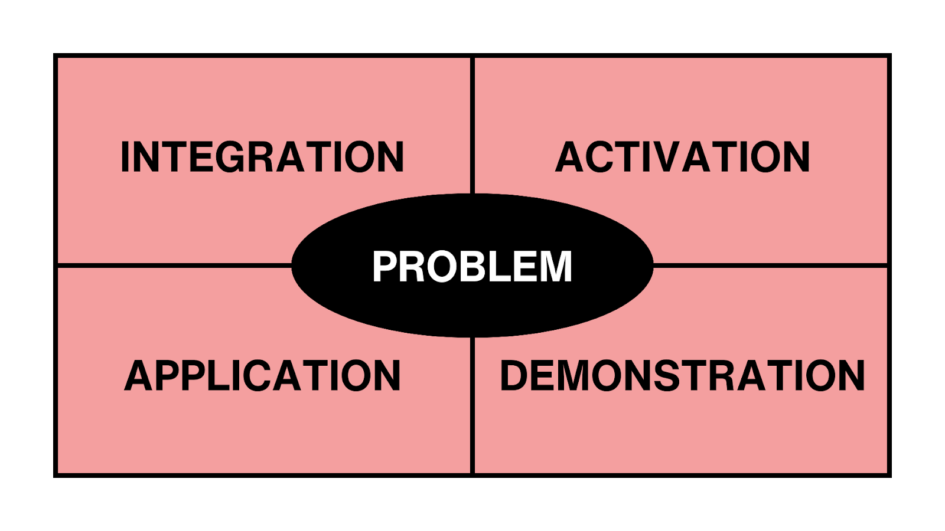

***Figure 1*** *First Principles of Instruction Conceptual Framework*

We chose this theory because it tackles the foundational facets of fostering effective learning. The learning objectives, activities, and assessment strategies embedded in the course will reflect these phases in a non-linear order to promote and enhance our audience's learning experience and gain success in their internship search and selection. Throughout the course, learners will employ prior knowledge gained through their exposure to IDT and the possible career paths the program leads to. They will enrich what they already know with further information provided in the course. The significant information they now have coupled with the guidance received through their access to resources will assist them in making a decision. Along with the assistance they will receive, the demonstrated knowledge and skills — with the help of templates and AI — will further improve their confidence and awareness. They can then capitalize on this information as they plan and produce their internship materials. To officially end their preparation and begin with the application, they will forward these materials to their companies of interest for internship consideration.

#### Curvilinear Depiction of Instruction Design

The researchers have concluded that using a non-linear instructional model is the most effective approach for developing this course. Adopting Branch & Dousay’s curvilinear model allows for continuous testing and refinement, enabling us to revisit and improve specific stages as needed before conducting a final summative evaluation. This model offers flexibility, which is especially beneficial for complex designs where the instructional content and learning objectives may evolve during development.

After conducting a thorough needs analysis, we successfully defined the instructional goal and identified key objectives that align with the learner’s needs and desired outcomes. The next steps involve determining the most appropriate instructional strategies to ensure these objectives are met effectively. For instance, problem-based learning or scenario-based instruction may be explored, depending on the content’s complexity and the learners’ prior knowledge. In addition, we will design formative assessments that provide ongoing feedback throughout the course, allowing us to identify areas where learners may need additional support and adapt the instruction accordingly. These assessments will align with the learning objectives and the overall instructional strategy, ensuring that they not only evaluate performance but also guide further learning.

Given the target audience’s preferences and technological access, we will carefully select appropriate multimedia tools, such as interactive videos or simulations, to enhance engagement. The multimedia will be chosen based on its relevance to the content, as well as its ability to facilitate hands-on learning and real-world application.

Throughout the entire process, the flexibility of the curvilinear approach ensures that we can make necessary adjustments without being locked into a rigid, linear development process, ultimately allowing us to deliver a more refined and effective instructional experience.

### Instructional (Learning) Objectives

By the end of this training, IDT graduate students will be able to:

1. Evaluate the unique IDT opportunities and challenges within corporate, non-profit, government, and formal education sectors.
2. Select the career path that aligns best with their professional goals and strengths.
3. Create a customized internship search plan that includes the use of various resources (online platforms, professional networks, and UT tools).
4. Use a template to compose a professional email to network with companies, organizations, and individuals in the IDT field.
5. Identify and apply for at least three (3) internship opportunities that align with their instructional design strengths using tailored application materials such as a resume, cover letter, and portfolio.

### Instructional Strategies - Design Blueprints

InterNavigate is an online, asynchronous module hosted in Articulate Rise 360 that will encourage interaction and engagement from the learners. We designed the course to be hands-on and practical to help IDT graduate students gather information and produce materials valuable to finding and applying for internships. We will employ the problem-based learning strategy where learners go through different stages to arrive at a solution. The instruction is 2 hours long and self-paced, where learners can decide when they are ready to proceed to the following phases of the course. We will use templates for guidance, multimedia to facilitate retention, and interactive formative assessments to promote learning. Some strategies we incorporated are discovery-based learning, active learning, direct instruction, individualized learner-centered instruction, instructional simulation, project-based learning, coaching, examples/non-examples, and more.

### Course Information

* **Course Title:** InterNavigate: Streamlining the IDT Graduate Internship Search
* **Course Overview:** We will use Merrill's First Principles of Instruction as our framework. The five key principles are: 1) problem, 2) activation, 3) demonstration, 4) application, and 5) integration. By following these principles, our goal is for learners to successfully apply for at least three instructional design internships by the end of the lesson. This lesson is designed to be a long-term resource for all IDT students for years to come.
* **Target Audience:**
  + Graduate students in the Instructional Design and Technology (IDT) program looking to apply for internships in different fields
  + Students are coming from various fields and industries including but not limited to formal education, government, corporate, or non-profit
  + Has completed IDT projects and has enrolled to at least 3-4 classes
  + Has finished EME 660 Seminar in Instructional Design
  + Able to write at a collegiate level
* **Duration:** 2 hours
* **Format:** Asynchronous, Self-Paced

### Lesson Topics, Format, and Assessment Template

#### Module 1: Exploring Career Paths (25 minutes)

**LO #1:** Evaluate the unique IDT opportunities and challenges within corporate, non-profit, government, and formal education sectors.

1. **Identify Difficulty in Finding IDT Internship**
   * + **Tool:** Articulate Rise 360, PADLET
     + **Media:** Text, Image, Linked Form
     + **Initial Presentation:** Learners are provided with a scenario-based prompt to reflect on challenges in securing an IDT internship
     + **Activity:** Learners will partake in a brainstorming session to discuss why finding an internship has been difficult so far. Learners will also discuss the help they think they need to be successful in their job search.
     + **Rationale:** Learners are encouraged to discuss issues that they are facing or hesitations that they have when it comes to finding an IDT internship.
     + **Theory:** Problem, Activation - learners are faced with a problem to solve as well as prompted to share their personal experience in the program. The activity requires their engagement and will activate prior knowledge.
     + **Pre-Assessment:** Participation, Reflection - learners will have the opportunity to share their thoughts through PADLET which they can access towards the end of the course and evaluate whether their concerns have been resolved.
2. **Career Path Exploration**
   * + **Tool:** Articulate Rise 360
     + **Media:** Text, Image, Video, Additional Links
     + **Initial Presentation:** Learners are presented with an interactive graphic that leads to more information on a specific career path.
     + **Activity:** Learners will engage with an interactive scenario where they explore four distinct career paths in instructional design: corporate, government, education, and non-profit careers. Brief summaries and key opportunities in each field are provided.
     + **Rationale:** This activity encourages learners to understand the diverse opportunities within the IDT field and supports decision-making by providing them with concise and relevant information.
     + **Theory:** Demonstration - Multimedia will be used to provide direct instruction as in the information learners might find useful in order to make a decision between the different IDT fields.
     + **Assessment:** Quiz - learners will be asked to perform a knowledge check for the career path/s they have chosen.

**LO #2:** Select the career path that aligns best with their professional goals and strengths.

1. **Quick Decision-Making**
   * + **Tool:** Articulate Rise 360, Google Forms
     + **Media:** Text
     + **Initial Presentation:** Learners will access a google form where they can choose a career path after being informed of the characteristics of each.
     + **Activity:** Learners select a preferred career path.
     + **Rationale:** This helps students practice decision-making in a time-efficient manner, ensuring they can justify their career preferences based on real-world scenarios.
     + **Assessment:** Reflection - provide a short explanation (2-3 sentences) for their choice.

#### Module 2: Planning for an Internship Search (25 minutes)

**LO #3:** Create a customized internship search plan that includes the use of various resources (online platforms, professional networks, and UT tools).

1. **Arranging Internship Planning Steps**
   * + **Tool:** Articulate Rise 360
     + **Media:** Text, Video
     + **Initial Presentation:** Present learners with key steps and examples for finding internships. Learners are provided with UT resources that can help guide them.
     + **Activity:** Learners are provided with a list of essential internship search steps (researching organizations, preparing documents, networking) and are asked to arrange these steps in the correct order using a drag-and-drop tool.
     + **Rationale:** This activity fosters reasoning and reinforces learners’ understanding of the process required for effective internship planning, ensuring they grasp the necessary steps in a manageable way.
     + **Theory:** Activation - this section of the material will require learners to recall their idea of the steps that might be beneficial to take when planning for an internship. This process will enhance their learning as they confirm or reassess what they already know.
     + **Assessment:** Formative, Procedural Sequencing - this step is a kind of formative assessment that will not only assess their understanding but will assist in their learning. This assessment will test their sequencing skills.
2. **Personalizing Quick Plan**
   * + **Tool:** Articulate Rise 360
     + **Media:** Text, Template
     + **Initial Presentation:** Learners are provided with a suggested template of steps to take when planning for their internship.
     + **Activity:** Learners complete a template with 3-4 key steps tailored to their personal internship search. This plan helps them begin strategizing in a concrete, personalized manner.
     + **Rationale:** By having a clear, personalized plan, learners can correct content to their specific career goals. It also reinforces planning and decision-making skills in a short, focused task.
     + **Theory:** Demonstration, Application -  the suggested template will serve as guidance to the learners but they can still exercise personal judgment and apply the information they have gathered through the previous activity to create their own plan.
     + **Assessment:** Practice, Project-based Learning - learners will have repeated exposure to the content this way and will be able to make a work of their own.

#### Module 3: Networking and Professional Communication (30 minutes)

**LO#4:** Use a template to compose a professional email to network with companies, organizations, and individuals in the IDT field.

1. **AI-Generated Email Draft**
   * + **Tool:** Articulate Rise 360
     + **Media:** AI Text Generator, Video
     + **Initial Presentation:** Learners are taught how to integrate AI in their writing process and are informed of its benefits. They will be provided with sample prompts to use when generating specific details using AI.
     + **Activity:** Learners will be introduced to an AI tool that helps them create a professional email template for networking. They then edit the draft to add personal details.
     + **Rationale:** This task introduces practical AI tools while allowing learners to focus on the critical aspect of personalization in professional communication.
     + **Theory:** Demonstration - the use of AI will provide guidance to the learners to easily start drafting their email for networking.
2. **Quick Email Writing**
   * + **Tool:** Articulate Rise 360, Padlet
     + **Media:** Text
     + **Initial Presentation:** Learners will go through suggestions that help them customize an email template.
     + **Activity:** Using the AI-generated draft as a base, learners create a personalized networking email to a senior or professional contact (no more than 5-6 sentences). They will be reminded to highlight their identified strengths in the IDT field.
     + **Rationale:** This activity emphasizes email etiquette, clarity, and the importance of concise professional communication, which is essential for networking.
     + **Theory:** Application, Integration - learners will build upon the knowledge they acquired through the previous activity to create and personalize an email template they can use for networking. They can integrate this process in their daily life.
     + **Assessment:** Practice, Formative, Project-based Learning - learners will have repeated exposure to the content this way and will be able to make a work of their own.
3. **Reaching Out for Advice**
   * **Tool:** Articulate Rise 360
   * **Media:** Text, Additional Links
   * **Initial Presentation:** Learners are provided with links to platforms where they can find connections with faculty.
   * **Activity:** Learners are encouraged to reach out to a faculty member for career advice, submitting a single question they would ask.
   * **Rationale:** Encouraging outreach practices helps learners build confidence in asking for advice and enhance their networking capabilities in a manageable time.
   * **Theory:** Integration - This exposure will build their confidence in reaching out to more individuals or organizations and widen their network of coverage with the IDT field.

#### Module 4: Designing Internship Materials (40 minutes)

**LO#5:** Identify and apply for at least three (3) internship opportunities that align with their instructional design strengths using tailored application materials such as a resume, cover letter, and portfolio.

1. **Resume & Cover Letter Creation**

* **Tool:** Articulate Rise 360
* **Media:** Text, Templates
* **Initial Presentation:** Learners are shown sample resumes, portfolios, and cover letters.
* **Activity:** Learners use pre-structured resumes, portfolios, and cover letter templates to fill in key information about their skills, experience, and career goals.
* **Rationale:** By using templates, learners can focus on content over formatting, ensuring they create professional materials quickly and efficiently. This also mirrors real-world tasks in the internship application process.
* **Theory:** Application - Learners will tailor their internship materials using the samples provided and use all the information and new knowledge they have acquired throughout the course to decide which data or artifacts to highlight.
* **Assessment:** Example/Non-examples, Project-based Learning - learners will be provided with effective and ineffective materials to compare from. They will be working on their personal materials that can be used for their applications.

**2. Submitting Applications**

* **Tools:** Articulate Rise 360
* **Media:** Application Materials
* **Initial Presentation:** Learners are reminded of what constitutes a suitable internship for them and are walked through the steps of application submission.
* **Activity:** Learners simulate submitting their applications to three organizations by selecting which documents (resume, cover letter) to send, and organizing them in a drag-and-drop format.
* **Rationale:** This step reinforces the final act of applying for internships and solidifies the experience of completing the process. It emphasizes the importance of being prepared and taking action.
* **Theory:** Application, Integration - As the final section of the course, this is where all their skills and knowledge will come together for the real-world to see.
* **Assessment:** Simulation, Reflection - This activity is a formative assessment where learners get to experience a simulation of the application process.



***Figure 2*** *Learner Objective Flowchart*

## 

## 

#### Example

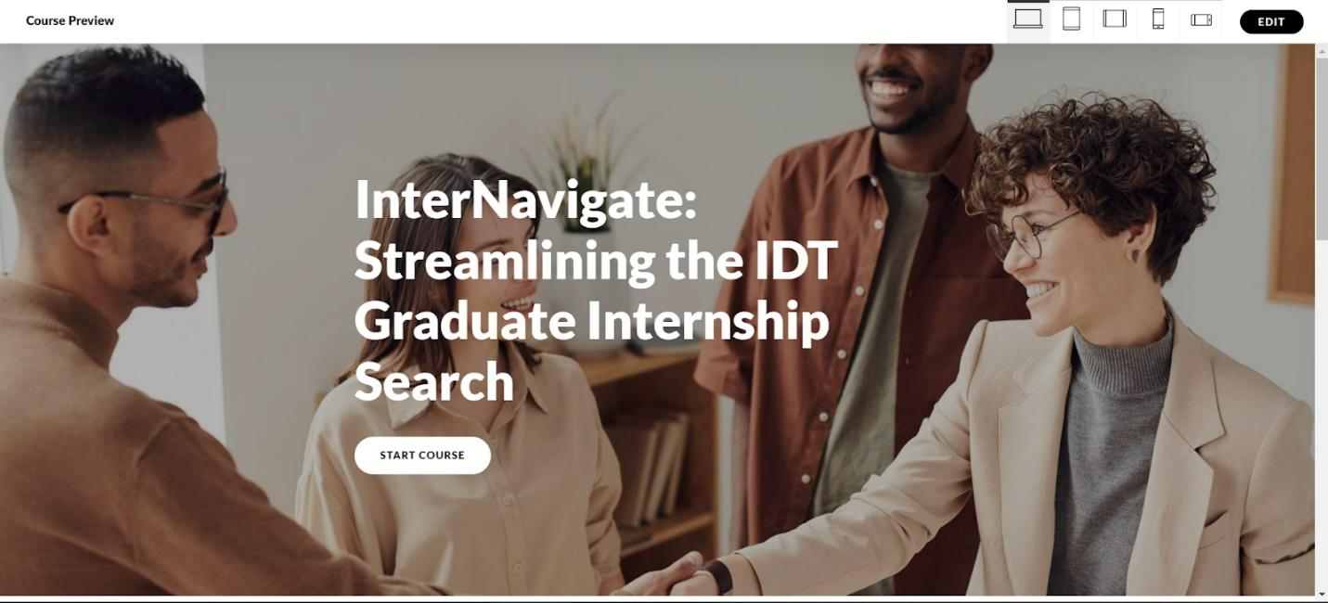

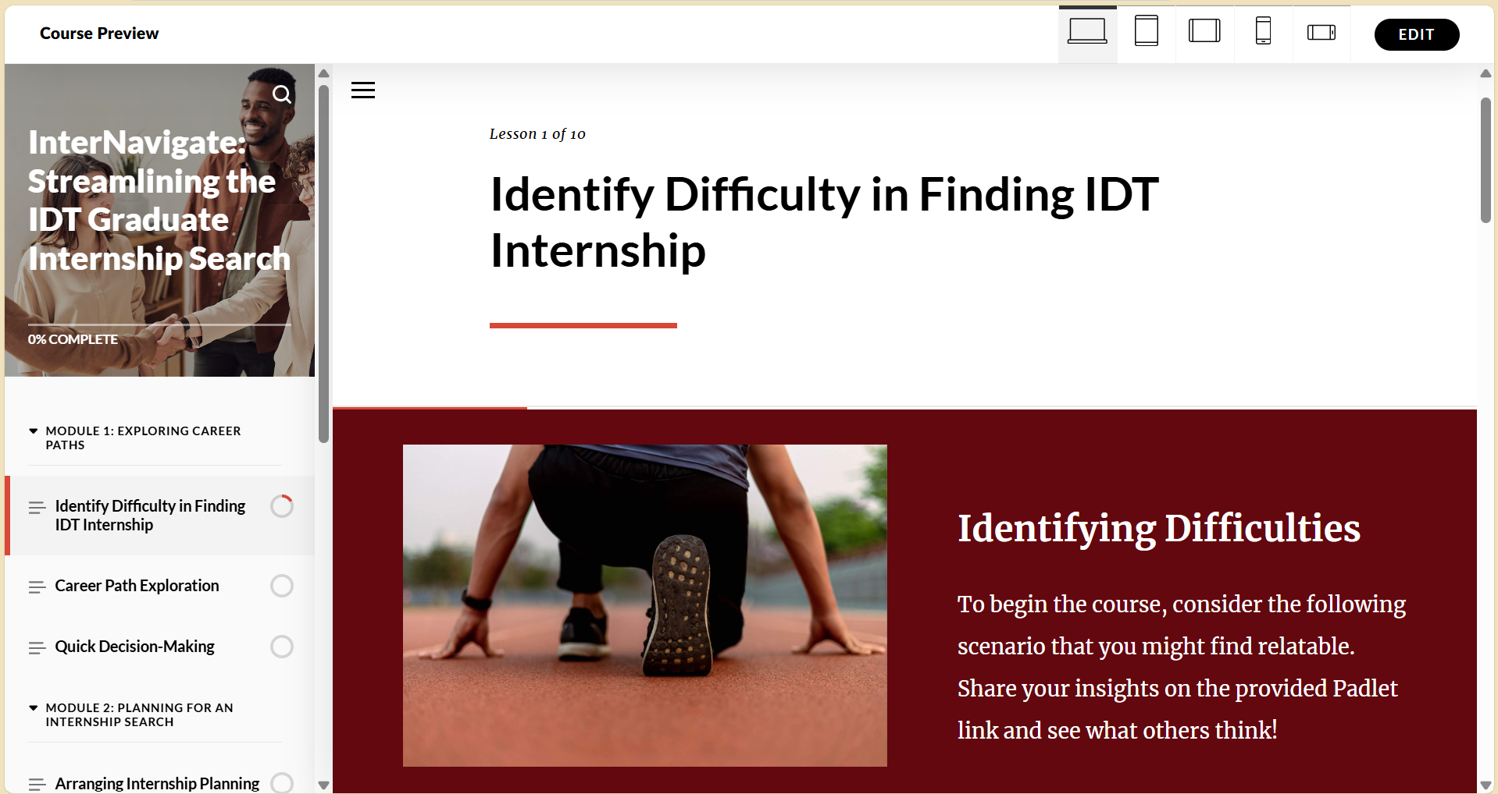

***Figure 3*** *Samples of InterNavigate in Articulate Rise 360*

#### Description of Flow

The flow of the learning process in *InterNavigate: Streamlining the IDT Graduate Internship Search* is non-linear because it allows learners to explore different career paths and internship-related tasks in a flexible and customizable order. Rather than following a strict sequence, learners can dive into areas based on their immediate needs or interests. Learners undergo the different phases of the First principles in different stages of the course and would perform some phases multiple times. There is not a set order of when they would encounter a problem, make use of prior knowledge or apply what they have learned.

#### Assessment Strategies

Throughout the course, we will implement various assessment strategies to evaluate learning progress. We’ll include independent practice, where learners engage in self-directed activities like quizzes and simulations. These will help learners navigate career paths and apply decision-making skills relevant to real-world internship searches.

Feedback will be integral to their development, providing timely insights through quizzes and peer evaluations to keep them aligned with course objectives. Additionally, we’ll utilize procedural sequencing, asking learners to arrange steps for effective internship planning, reinforcing logical reasoning and problem-solving skills.

Towards the end of the course, we’ll include a reflective practice component, to make way for the assessment of learning experiences and identify areas for growth. We will also provide a feedback form through Qualtrics to gather thoughts on the course. Finally, the final project will involve creating tailored internship materials, such as a resume and cover letter, to submit to at least three organizations.

By integrating these strategies — independent practice, timely feedback, procedural sequencing, reflective practice, and a final project — we aim to ensure learner engagement and support in achieving the learning objectives for an internship search. These assessment strategies are grounded in effective learning design principles, ensuring a scaffolded approach to learning that progresses from exploration and feedback to reflection and real-world application.

## Instructional Materials

**Lesson Title:** [InterNavigate: Streamlining the IDT Graduate Internship Search](https://rise.articulate.com/share/U7NiIT9PXQmnqDGgeOWSjq_0GppsuZMJ#/)

**Target Learners:** Current IDT Students

**Lesson Format:** Rise 360

**Instructional Goal:** By the end of this training, IDT graduate students will be able to demonstrate preparedness when applying for an internship.  
**Instructions:** Use the Group 4 Lesson link to access the modules. The lesson may take up to 2 hours.  
[**Instructional Guide**](https://docs.google.com/document/d/10aKZcbrYfXxRDGyLJxzjBllKdMUGd-J_j_99JKt5ZA0/edit?usp=sharing)

## Formative Evaluation

[**Usability Test**](https://utampa.az1.qualtrics.com/jfe/form/SV_5psimNj05ZHznQW)

The usability test aimed to evaluate the effectiveness of the lesson in teaching the stated objectives, ease of use, and overall satisfaction. A Qualtrics Survey was used to collect data from learners who had just completed the lesson. The survey included a mix of Likert scale questions and open-ended feedback options to capture more detailed insights.  **Evaluation Methodology**

* **Evaluation Type:** Likert Scale Survey and Open-Ended Feedback
* **Platform:** Qualtrics Survey
* **Learners:** Five individuals who engaged with and completed the course
* **Data Collection Tools:** Several of the questions utilized a 5-point Likert scale, ranging from "strongly disagree" to "strongly agree," as well as other phrasing variations such as "definitely not" to "definitely yes," "extremely difficult" to "extremely easy," and "not well at all" to "extremely well." These scales were complemented by open-ended comment sections for additional feedback, allowing learners to provide more detailed responses alongside their ratings.
* **Metrics Used:** Agreement levels on key aspects (stated objectives, organization, activities, assessments, visuals) and qualitative feedback from the open-ended responses

### Formative Evaluation Report

This formative evaluation report summarizes the findings from a usability test conducted for InterNavigate: Streamlining the IDT Graduate Internship Search.

### Usability Test Material

**InterNavigate: Streamlining the IDT Graduate Internship Search**

How would you rate your overall experience with the **InterNavigate** course?

* Extremely dissatisfied
* Somewhat dissatisfied
* Neither satisfied nor dissatisfied
* Somewhat satisfied
* Extremely satisfied

What are your thoughts on the length of the lesson?

* Could Have Been Shorter
* Right Amount of Time
* Could Have Been Longer

Did you encounter obstacles that slowed you down while completing the course?

* No
* Yes
* If yes, can you name them? __________________________________________________

Did you find the objectives and instructions in each module clear?

* Definitely not
* Probably not
* Might or might not
* Probably yes
* Definitely yes

Is the text legible and easy to read across all modules?

* Strongly disagree
* Somewhat disagree
* Neither agree nor disagree
* Somewhat agree
* Strongly agree

Do the icons and images used in the design clearly represent their intended functions or messages?

* Strongly disagree
* Somewhat disagree
* Neither agree nor disagree
* Somewhat agree
* Strongly agree

Did you find the layout and design of the course interface intuitive?

* Strongly disagree
* Somewhat disagree
* Neither agree nor disagree
* Somewhat agree
* Strongly agree

Did you find the modules easy to navigate?

* Extremely difficult
* Somewhat difficult
* Neither easy nor difficult
* Somewhat easy
* Extremely easy

Can you provide specific feedback on your experience navigating the modules? What aspects were intuitive, and where did you encounter challenges?

________________________________________________________________

________________________________________________________________

Did you find the course content well-planned and organized?

* Strongly disagree
* Somewhat disagree
* Neither agree nor disagree
* Somewhat agree
* Strongly agree

Did you find the content and resources engaging?

* Strongly disagree
* Somewhat disagree
* Neither agree nor disagree
* Somewhat agree
* Strongly agree

Did you find the resources helpful in preparing for your internship search?

* Definitely not
* Probably not
* Might or might not
* Probably yes
* Definitely yes

Which module did you find the most thought-provoking? Please rank them in order of impact, starting with the one you found most engaging and ending with the least.

______ Module 1: Exploring Career Paths

______ Module 2: Planning for an Internship Search

______ Module 3: Networking and Professional Communication

______ Module 4: Designing Internship Materials

How well do you feel you would remember the key concepts covered in this course?

* Not well at all
* Slightly well
* Moderately well
* Very well
* Extremely well

What key insights or takeaways did you gain from the **InterNavigate**course?

________________________________________________________________

________________________________________________________________

Any additional comments?

________________________________________________________________

________________________________________________________________

Thank You for Completing the Survey! We appreciate your time and valuable feedback. Your responses will help us enhance the InterNavigate experience and better support IDT graduate students in their internship search. If you have any additional thoughts or suggestions, feel free to reach out! Thank you again for your input and participation.

### Summary

*Overall Experience*

Based on the learner feedback, the overall experience with the InterNavigate course was largely positive. When asked, "How would you rate your overall experience with the InterNavigate course?" 60% of learners rated it as "extremely positive," while 40% indicated a "somewhat positive" experience. Regarding specific aspects, 50% of learners found the course interface somewhat intuitive, while 50% strongly agreed it was user-friendly. Learners consistently found the modules extremely easy to navigate, with 100% expressing satisfaction in this area. In terms of organization, 75% of learners strongly agreed the content was well-planned and organized, while 25% somewhat agreed. Overall, the majority of learners found the course highly beneficial, though a smaller portion noted areas for potential improvement, particularly in the interface design.

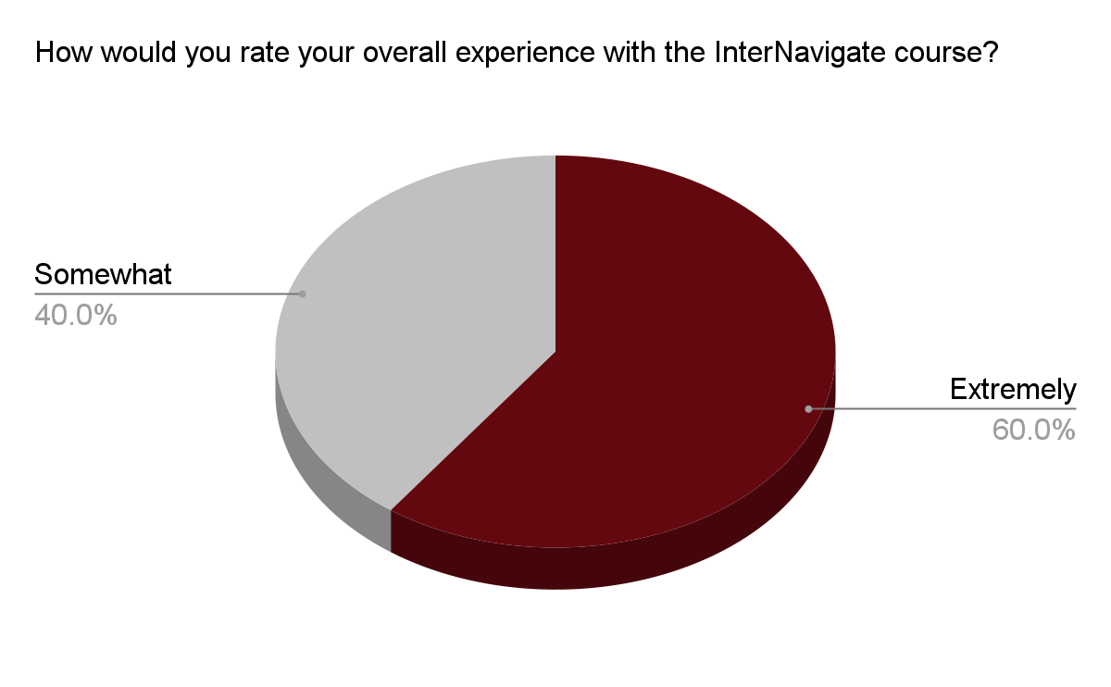

*Lesson Duration*

Based on the learner feedback regarding the lesson duration, 80% of learners felt that the lesson length was just right, while 20% suggested it could have been shorter. Overall, the majority of learners found the timing to be appropriate, complementing the course’s intuitive design, easy navigation, and well-organized content. This feedback indicates that the course structure aligns well with learner expectations, with only a small percentage expressing a desire for shorter lessons.

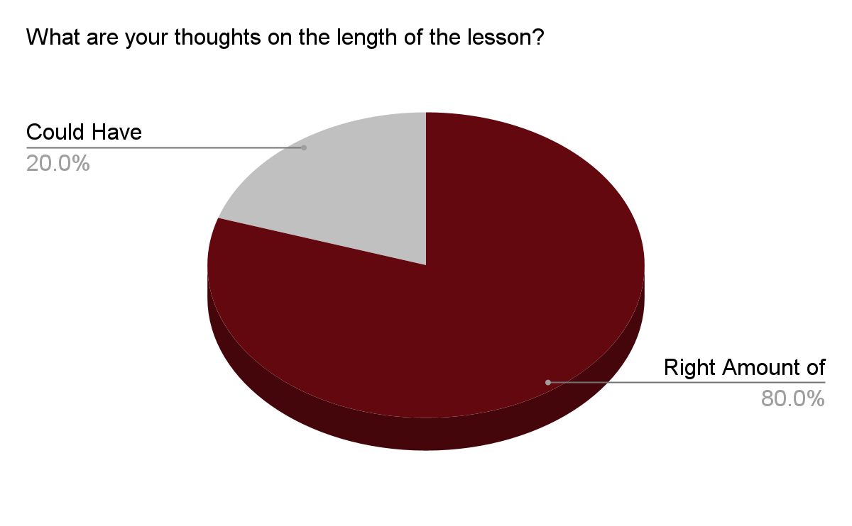

| I got caught in a looped cycle of answering the same question repeatedly in Lesson 2's knowledge check. |
| --- |
| I wouldn't say there were major obstacles, but I did need some extra time to fully understand the different functions of IDT across various settings like government, corporate, and non-profit sectors |

*Clarity*

Based on the learner feedback, 100% of learners found the objectives and instructions in each module to be clear, with 75% saying "definitely yes" and 25% saying "probably yes." Regarding the clarity of text legibility, 100% of learners agreed it was easy to read, with 75% strongly agreeing. For the design elements, such as icons and images, 50% of learners somewhat agreed and 50% strongly agreed that they clearly represented their intended functions or messages.

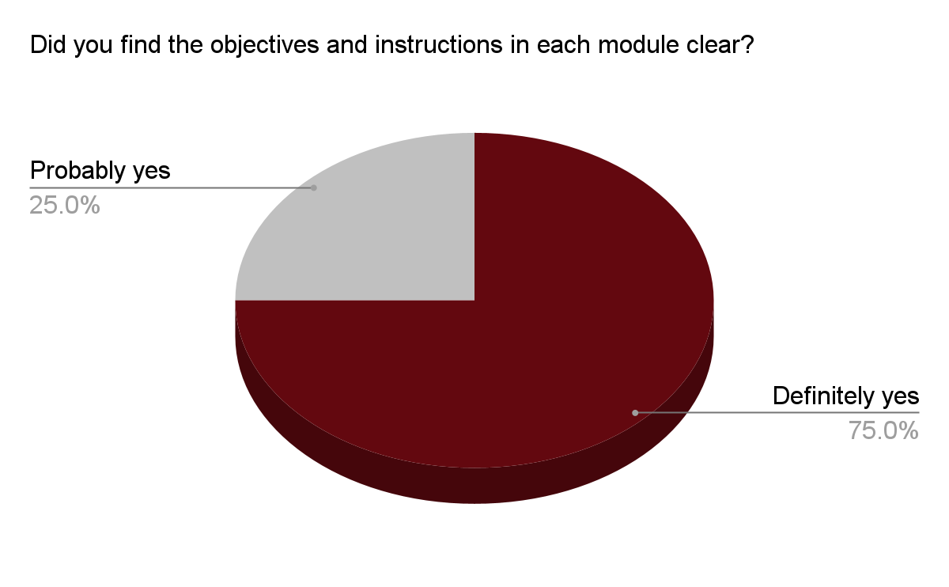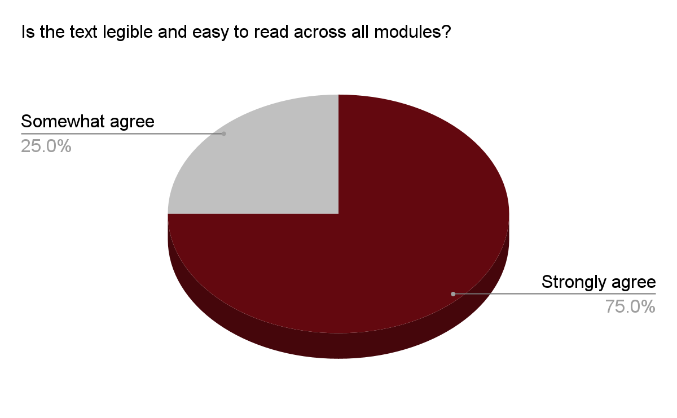

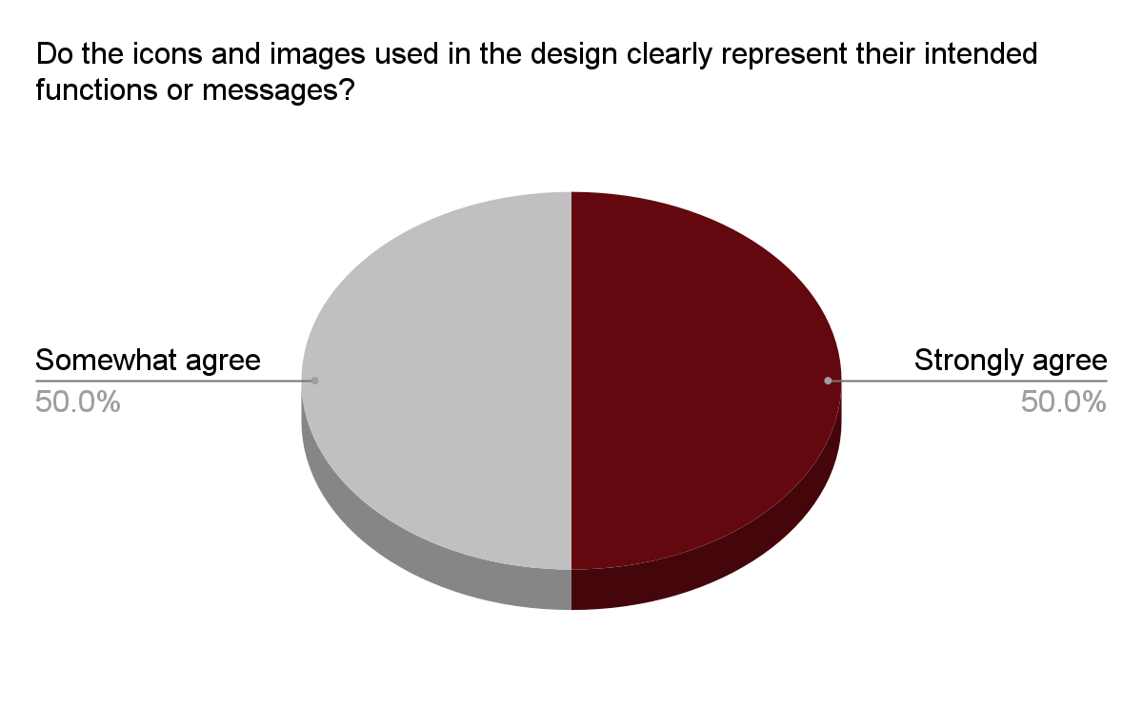

*Organization and Navigation*

Based on the learner feedback, the course interface was well-received, with 50% of learners finding the layout and design somewhat intuitive and 50% strongly agreeing that it was user-friendly. Learners consistently found the modules extremely easy to navigate, with 100% expressing a positive experience in this area. Regarding the course content, 75% of learners strongly agreed that it was well-planned and organized, while 25% somewhat agreed. Overall, learners highlighted the course’s effective navigation and organization, though there is potential for minor improvements in the interface design.

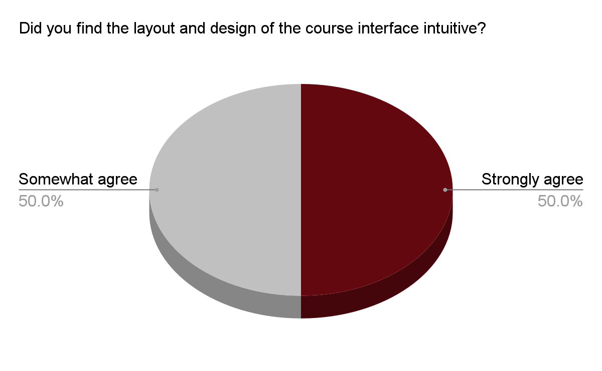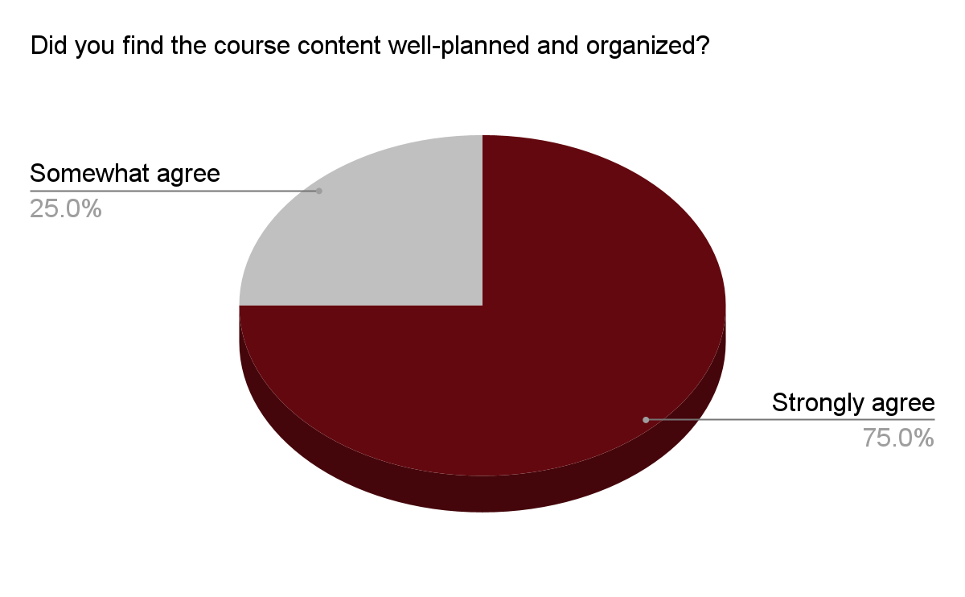

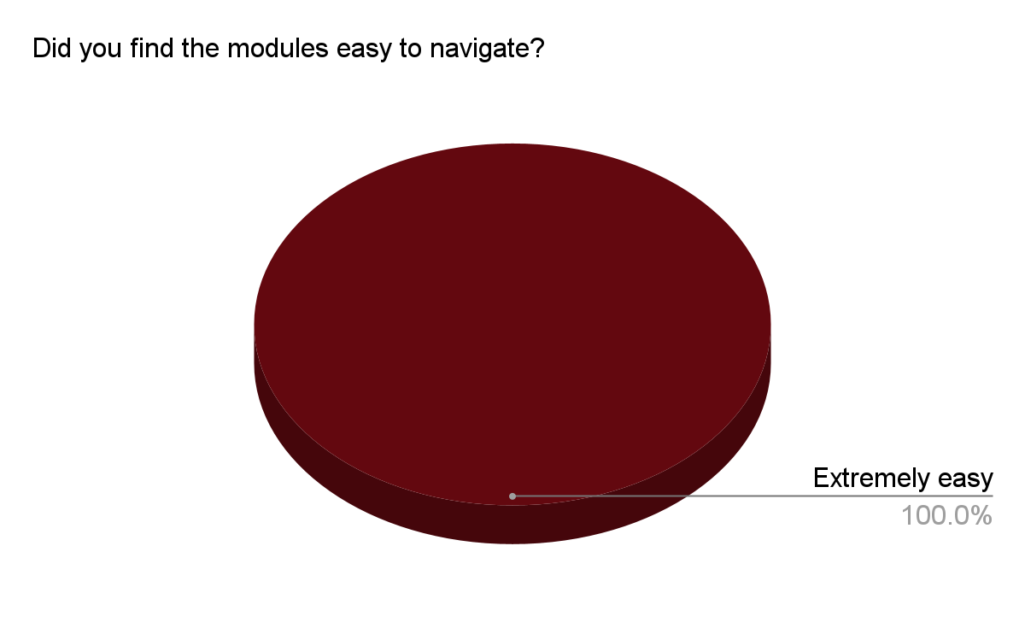

*Constructive Feedback*

Based on the learners' open-ended feedback, learners were highly satisfied with the course’s navigation and intuitiveness. They appreciated the logical flow of the modules and how the material built upon itself, leading to the overall instructional goal. The ease of accessing quizzes and videos, as well as the clarity of step-by-step instructions, was praised. However, one piece of constructive feedback suggested improving the knowledge check in Lesson 2, specifically ensuring learners are aware they need to close the tab upon completing the quiz.

To improve, we could add a clearer prompt or visual cue to remind learners to close the tab after the quiz to avoid confusion. Additionally, providing an option for learners to revisit sections with ease could further enhance the clarity of the course materials. These adjustments would refine the overall user experience and address the minor issues raised in the feedback.

Can you provide specific feedback on your experience navigating the modules? What aspects were intuitive, and where did you encounter challenges?

| Your course was straightforward to navigate and quite intuitive. If I were to change anything, I would look at the knowledge check in lesson 2 to ensure that learners know they need to close the tab upon completing the quiz question. Otherwise, I was very impressed by the navigational intuitiveness of your course. |
| --- |
| I thought that the module was straightforward to navigate and that the lessons were presented in a logical order. I felt the material built upon itself until the learner met the true goal of the instruction. |
| The module was easy to navigate as everything was explained thoroughly. Great job. |
| Seemed well made and professional |
| The modules were intuitive, with a smooth flow between sections. I especially liked how easy it was to access quizzes and videos, which made learning engaging. The step-by-step instructions were clear, though I occasionally revisited previous sections for clarity. Overall, the design made navigation simple and enjoyable. |

*Relatability, Recall, and Engagement*

Based on learner feedback, the course’s relatability, recall, and engagement were generally positive. In terms of engagement, 50% of learners somewhat agreed and 50% strongly agreed that the content and resources were engaging. Regarding the usefulness of the resources, all learners (100%) found them highly helpful in preparing for their internship search. When asked to rank the modules based on impact, learners found Module 1 to be the most thought-provoking, with an average ranking of 1.75, followed by Module 4 (2.5), Module 3 (2.75), and Module 2 (3). These rankings suggest strong relatability and recall from the learners, particularly in Modules 1 and 4.

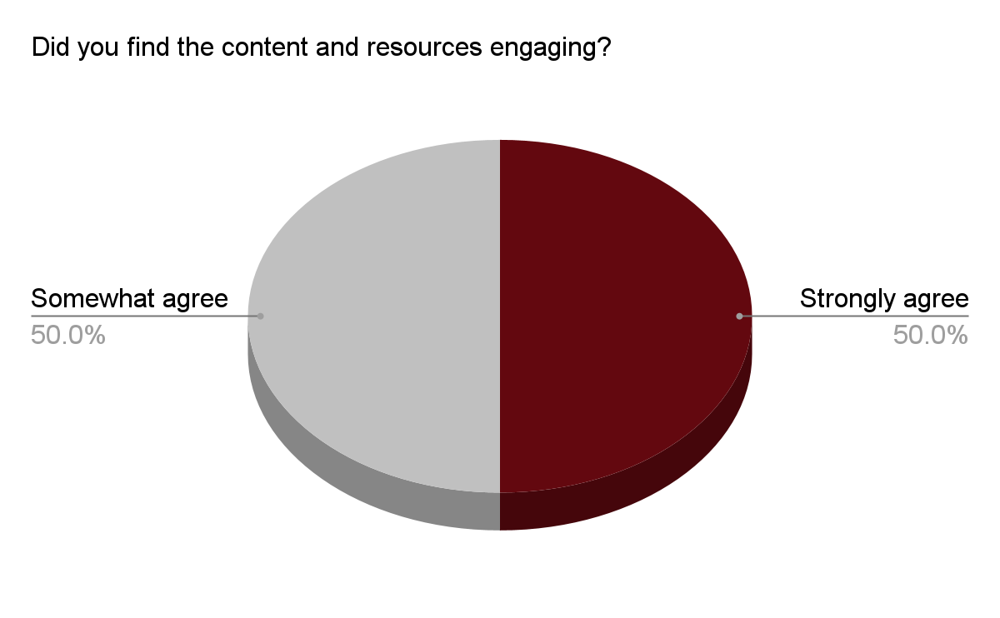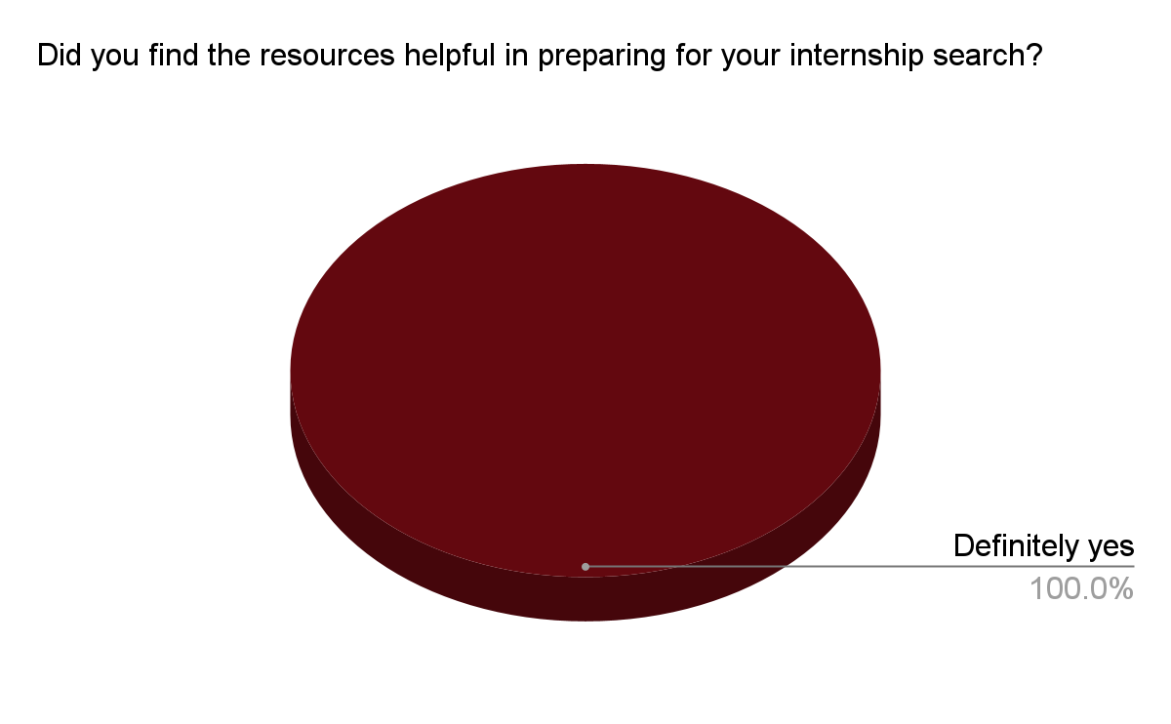

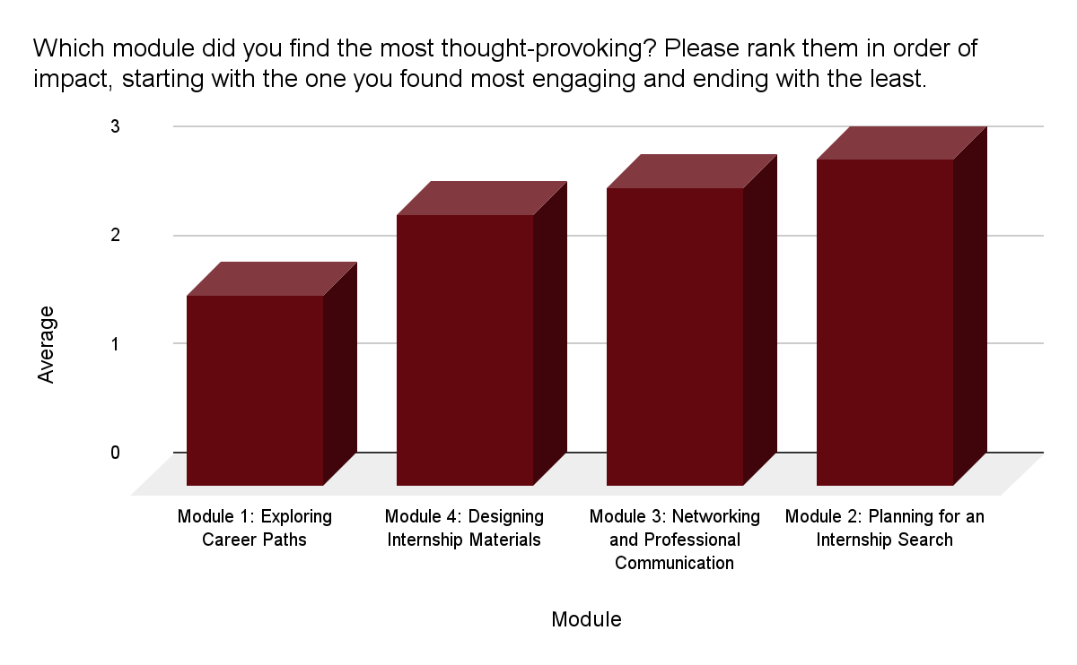

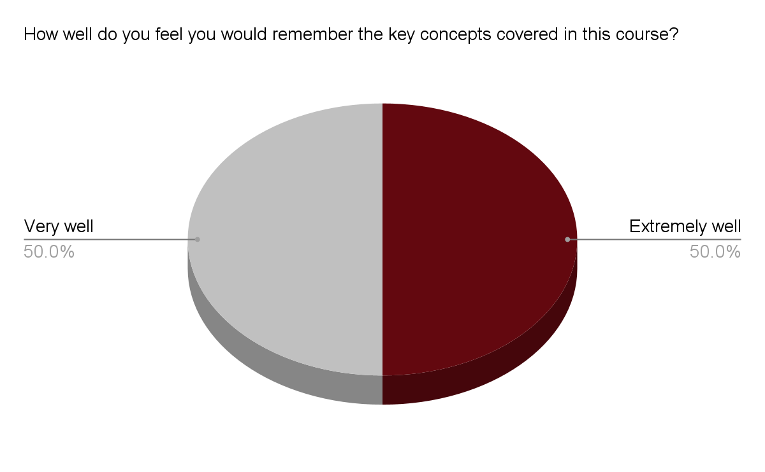

What key insights or takeaways did you gain from the InterNavigate course?

| I learned a lot about the resources offered at the University of Tampa and I hope to take full advantage of the services offered by the Career Services Department as I prepare for my internship. |
| --- |
| I learned about the resources available at the University of Tampa. I plan to utilize the services offered by the Career Services Department to proof my application materials and to seek out internship opportunities applicable to my interests. |
| The career paths exploration was extremely helpful. I am new to IDT and still unsure of where I want to end up. This helped with a peace of mind in narrowing my search for an internship. |
| Helpful resume tips |
| Initially, I felt a bit confused about the layout and content, but as I moved forward, the course made everything much clearer. I loved how simple and straightforward the materials were, making the learning process feel approachable. The quizzes were a fun way to reinforce what I learned, and the videos offered valuable insights. One standout feature was the tutorial on how to make not just a resume and cover letter, but an effective one that truly stands out to employers. It was a great takeaway, showing how clarity and strategy can make all the difference in job applications. |

*Additional Comments*

Learners provided highly positive feedback in their additional comments, expressing that they were "very impressed" with the course. It was clear that the group invested significant time and effort into developing both the concept and materials. One learner highlighted the exceptional quality of the procedural instruction and emphasized that the group should be proud of their work, calling it "fantastic." The comments reflect a high level of satisfaction with the course design and execution.

Any additional comments?

| I was very impressed with your course. It is evident that your group invested a great deal of time and effort into your concept and materials. I hope you're proud of your output! |
| --- |
| Fantastic work. Your group did an exceptional job creating your procedural instruction. |

## Implementation Plan for InterNavigate

**Instructional Delivery**

What is the primary instructional delivery method? Select all that apply.

* Online Learning
* Classroom
* Webinar
* Manual
* Blended (Classroom & Online)

**Communication Plan**

1. **Instructional Delivery and Support Team**

* **Instructors and Role**

*InterNavigate* is a fully online, self-paced, 2-hour course delivered asynchronously via Articulate Rise. While there are no live sessions, Instructors are available to support learners, answer questions, and provide technical assistance.

* **Instructor Preparation**
  + **Orientation:** Instructors will participate in a brief orientation to learn about *InterNavigate*, familiarize themselves with Merrill’s First Principles framework, and understand the instructional goals and structure. This will prepare them to confidently guide students through the course and offer consistent support.
  + **Implementation and Monitoring:** Instructors will oversee learner progress through Articulate Rise, offering guidance and answering questions as learners work through the self-paced modules.
  + **Sustainability:** Instructors will conduct quarterly reviews to assess learner feedback, course analytics, and make updates, ensuring the course remains relevant and effective.
* **Motivation to Implement**

Instructors are motivated to implement *InterNavigate* because it provides a streamlined, effective approach to internship preparation. This course helps learners develop essential job-seeking skills, fostering independence in the internship search process. Providing valuable support as learners pursue internships, supplementing one-on-one career guidance with an additional resource.

2. **Learner Communication**

* **Course Introduction**
  + **Initial Email:** Learners will receive a welcome email from instructor or career services, introducing *InterNavigate*, highlighting its self-paced structure, and outline the course’s practical benefits and learning objectives.
* **Ongoing Communication**
  + **Automated Reminders**: Articulate Rise will send automated reminders encouraging learners to continue progressing through the 2-hour self-paced modules.
  + **Announcements:** A “Course Announcements” section within Articulate Rise will share any updates or additional resources, ensuring learners have access to the latest information.

**Change Management Plan**

**1. Impact of Processes**

* **Streamlined Internship Prep:** *InterNavigate* helps students take charge of their internship search with a structured, step-by-step approach. This makes students less dependent on career services for the basics, letting career counselors focus on more complex guidance.
* **Increased Independence:** The self-paced, online setup encourages students to manage their own learning and build confidence in the job search skills, setting them up for future success.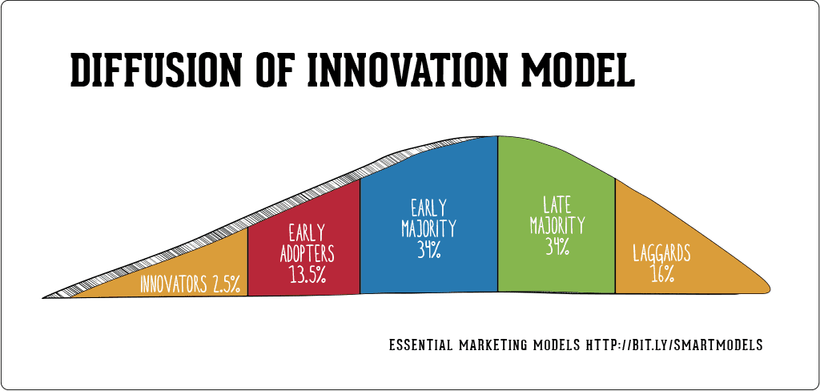

**2. Adapting to Changes**

* **Using Roger’s Diffusion of Innovation**
  + **Innovators and Early Adopters:** Motivated students, instructors, and career staff can serve as advocates by sharing positive experiences and tips.
  + **Gradual Rollout:** Real-life success stories and testimonials will help students who are less familiar with self-paced courses feel comfortable.
  + **Support for All Learners:** Learners can review Articulate Rise tutorials if they need additional guidance on navigating the course content, helping them feel comfortable with the platform.

**Delivery Date**

With a planned launch date of January 21, 2025, for *InterNavigate*, several potential risks and constraints could affect the timeline:

* **Technical Challenges:** Issues with the Articulate Rise platform could prevent some instructors and learners from accessing the course due to compatibility problems, login issues, or unstable internet connections, which could affect participation and engagement in the course.
* **Accessibility and Compliance:** Ensuring that the course meets all accessibility and university standards may require additional reviews and edits, which could delay the launch.
* **Third-Party Platform Dependencies:** Our reliance on platforms like Qualtrics for surveys and Padlet for discussion boards means any technical issues or outages could disrupt the course experience.

**Training Curriculum and Schedule**

| **Module 1: Exploring Career Paths** | | | |
| --- | --- | --- | --- |
| **Learning Objective #1:** Evaluate the unique IDT opportunities and challenges within corporate, non-profit, government, and formal education sectors. | | | |
| **Module 1 Duration Time:** 25 minutes | | | |
| **Lesson #** | **Lesson Title** | **Audience** | **Tools** |
| #1 | Identify Difficulty in Finding IDT Internship | Learners (IDT Graduate Students) | Articulate Rise 360, Google Form, PADLET |
| #2 | Career Path Exploration | Learners (IDT Graduate Students) | Articulate Rise 360 |
| **Learning Objective #2:** Select the career path that aligns best with their professional goals and strengths, utilizing the resources and guidance provided by UT. | | | |
| #3 | Quick Decision-Making | Learners (IDT Graduate Students) | Articulate Rise 360 |

| **Module 2: Planning for an Internship Search (25 minutes)** | | | |
| --- | --- | --- | --- |
| **Module 2 Duration Time:** 25 minutes | | | |
| **Learning Objective #3:** Create a customized internship search plan that includes the use of various resources (online platforms, professional networks, and UT tools). | | | |
| **Lesson #** | **Lesson Title** | **Audience** | **Tools** |
| #1 | Arranging Internship Planning Steps | Learners (IDT Graduate Students) | Articulate Rise 360 |
| #2 | Personalizing Quick Plan | Learners (IDT Graduate Students) | Articulate Rise 360 |

| **Module 3: Networking and Professional Communication** | | | |
| --- | --- | --- | --- |
| **Learning Objective #4:** Use a template to compose a professional email to network with companies, organizations, and individuals in the IDT field. | | | |
| **Module 3 Duration Time:** 30 minutes | | | |
| **Lesson #** | **Lesson Title** | **Audience** | **Tools** |
| #1 | AI-Generated Email Draft | Learners (IDT Graduate Students) | Articulate Rise 360 |
| #2 | Quick Email Writing | Learners (IDT Graduate Students) | Articulate Rise 360 |
| #3 | Reaching Out for Advice | Learners (IDT Graduate Students) | Articulate Rise 360, PADLET |

| **Module 4: Networking and Professional Communication** | | | |
| --- | --- | --- | --- |
| **Learning Objective #5:** Identify and apply for at least three (3) internship opportunities that align with their instructional design strengths using tailored application materials such as a resume, cover letter, and portfolio. | | | |
| **Module 4 Duration Time:** 30 minutes | | | |
| **Lesson #** | **Lesson Title** | **Audience** | **Tools** |
| #1 | Resume & Cover Letter Creation | Learners (IDT Graduate Students) | Articulate Rise 360 |
| #2 | Submitting Applications | Learners (IDT Graduate Students) | Articulate Rise 360 |

**Training Logistics**

**1. Required Logistics for Training**

* **Essential Resources:**
  + Provide Articulate Rise access links for participants to engage with the course modules and activities.
  + An instructor's digital guide covering course objectives, structure, and support options.
  + Include troubleshooting Frequently Asked Questions and contact information for assistance with Articulate Rise.

2. **Preparing for Delivery**

* **Setup and Testing:**
  + Set up and verify user accounts and permissions on Articulate Rise.
  + Test links and digital resources to confirm functionality.
* **Instructor Preparation:**
  + Email instructors with access links, the instructional guide, and tech support contact details.

3. **Getting Materials to Instructors**

* **Digital Distribution:**
  + Send all materials, including the instructional guide and access instructions, via email to instructors for review.
  + Schedule a quick optional pre-training check-in to discuss logistics, answer questions, and confirm readiness.

**Instructional Designers’ Roles**

| **Team Member** | **Responsibilities** | **Reflection** |
| --- | --- | --- |
| **Asia Brown** | * Editing * Examples * Flowchart * Submission * Review | Creating this document was a new experience for me. It took a lot of collaboration and long hours to achieve our final product. We were in constant contact with each other and were able to effectively collaborate.  I contributed to the Articulate module and the designing of our final documents. I made sure to submit assignments on time after consulting with the group. |
| **Melanie White** | * Assessment Strategies * Course Information * Editing/Revising * Learner Objectives * Instructional Structure * Implementation Plan | In the InterNavigate Project, I contributed significantly by shaping core elements of the course design. I developed the course structure, including module titles, lessons, tools, activities, and setting durations. Additionally, I created modules within Articulate, designed instructional strategies, and crafted an implementation plan to guide the course’s rollout. I also assisted in interpreting data from the utilization tool, ensuring we used insights to improve our approach. My contributions extended to developing assessment strategies, organizing course information, editing content, defining learner objectives, and designing instructional activities to create a cohesive learning experience.  **Team Dynamics** Our team thrived in a collaborative environment, staying connected through WhatsApp, Zoom, and feedback on our Google Doc. Every member brought thoughtful ideas, gave constructive feedback, and contributed to a supportive atmosphere. This open communication was key to our project’s success and made working together productive and enjoyable. |
| **Polleana Mary Muñoz** | * Flow * Introduction * Instructional Blueprints * Instructional Objectives * Instructional Strategies | **Contributions:** My contributions included initiating ideas, organizing our work structure, and brainstorming approaches for the instructional material. I helped the group identify an appropriate theory for our design direction. I provided foundational ideas that my roommates built upon, essential for the course's effectiveness and completion. I also refined other document sections and transformed the instructional material from a set of objectives into an interactive resource for IDT Graduate students looking to intern.  **Team Dynamics:** We consistently communicated about tasks and improvements. Using a shared Google Docs file, we added and finalized our information. Contributions and changes were documented to reach our final outcome. We equally distributed the workload and accommodated each other's circumstances, practicing respect at all times. |

## 

## Summative Evaluation

**Summative Evaluation Plan**

*Measuring Success*

InterNavigate is a tool designed to assist IDT graduate students in preparing for the internship application process. Success in the course is measured by each learner's completion of the tasks within the curriculum. PADLET discussions will provide a way for the instructor to monitor student participation, as they describe potential challenges they might face, draft sample networking emails, and reach out to faculty for advice. In addition to PADLET, Google Forms and other knowledge-check tools will be used to gather responses and assess retention of direct instruction, including the steps they need to follow. Lastly, the materials students produce—such as their internship search plan, resume, portfolio, and cover letter—will be evaluated using a rubric based on the parameters and templates provided in the course. When students are able to perform these tasks at an above-average level, they are considered prepared for the internship application process.

*Effectiveness and Efficiency*

To further validate the results described above, a survey will be conducted on how the course met the learning objectives, directly gathering learners' feedback on their experience. The following questions will be used to assess the effectiveness and efficiency of the InterNavigate course.

**InterNavigate Summative Evaluation Survey**



*Course Effectiveness*

On a scale of 1 to 5, with 5 meaning "definitely yes," please rate the following statements.

|  | 1 | 2 | 3 | 4 | 5 |
| --- | --- | --- | --- | --- | --- |
| I am able to identify potential IDT internship difficulties through Module 1 of the InterNavigate course. | o | o | o | o | o |
| I acquired a great deal of information regarding attributes of several IDT career paths. | o | o | o | o | o |
| I made an informed decision on a career path to focus on for internship applications. | o | o | o | o | o |
| The career path I chose aligns with my professional goals and strengths. | o | o | o | o | o |
| With the activities in Module 2, I successfully created a customized internship search plan. | o | o | o | o | o |
| I used AI to help form a foundation for writing a professional networking email. | o | o | o | o | o |
| Through Module 3, I created a professional email template for networking. | o | o | o | o | o |
| I designed a resume, portfolio, and cover letter that highlight my strengths and align with my chosen career path. | o | o | o | o | o |
| After preparing through the InterNavigate course, I can confidently submit applications. | o | o | o | o | o |

Do you feel more confident searching and applying for internships after completing the course?

o Definitely not

o Probably not

o Might or might not

o Probably yes

o Definitely yes

*Course Efficiency*

Did you think two hours would be sufficient to finish the course?

o Definitely not

o Probably not

o Might or might not

o Probably yes

o Definitely yes

How much longer do you think you would require if you needed additional time?

o 15 mins.

o 30 mins.

o 45 mins.

o 60 mins.

o More than 60 mins.

Did you think the templates, examples, and other resources were enough to help you complete the course on schedule?

o Definitely not

o Probably not

o Might or might not

o Probably yes

o Definitely yes

If not, what changes would you recommend we make?

________________________________________________________________

________________________________________________________________

________________________________________________________________

Did the instructor provide you enough direction?

o Definitely not

o Probably not

o Might or might not

o Probably yes

o Definitely yes

Do you think having more instructors would make it easier for you to finish the course and its materials quickly and efficiently?

o Strongly disagree

o Somewhat disagree

o Neither agree nor disagree

o Somewhat agree

o Strongly agree

Are you comfortable using the prescribed equipment (laptop or computer) to finish the course?

o Extremely uncomfortable

o Somewhat uncomfortable

o Neither comfortable nor uncomfortable

o Somewhat comfortable

o Extremely comfortable

To find out what the instructors think could be done to make the course better, a focus group discussion will be conducted. The following questions will be asked:

* Do you think 2 hours is sufficient to complete the course?
* Are the provided materials effective in helping learners meet the objectives?
* Does the instructional guide provide enough information for instructors to conduct the course?
* Do you have any recommendations for improving the course?

*Evaluation*

To generate a comprehensive analysis of results, we will use a combination of performance metrics based on course assessment strategies, the survey tool above to understand learners’ experiences, and the focus group discussion from the instructor’s perspective. Performance metrics will be collected during the course, while the survey and focus group discussion will occur at the end of the lesson. Survey questions will be printed and distributed to learners. IDT instructors, preferably those in charge of EME 660 and EME 661 Seminar classes, as well as EME 650 Field Internship, will gather after implementing and moderating the course. The results will guide designers on necessary changes, what should be retained, and areas for improvement to enhance future course implementation.

## References

Anderson, T. (2008). *The theory and practice of online learning*. Athabasca University

Press.[https://www.aupress.ca/app/uploads/120146_99Z_Anderson_2008-Theory_and_P](https://www.aupress.ca/book/the-theory-and-practice-of-online-learning/)

[ractice_of_Online_Learning.pdf](https://www.aupress.ca/book/the-theory-and-practice-of-online-learning/)

Branch, R.M. (2017). Ch. 3 Characteristics of foundational instructional design model. In R.A.

Reiser & J.V. Dempsey (Eds.), Trends and Issues in Instructional Design and Technology (4th ed.). Boston, MA: Pearson Education.

Branch, R. M., Mané, C. E., & Shin, M. Y. (2018). Effect of graphic element type on visual

perceptions of curvilinear and rectilinear flow diagrams. Journal of Visual Literacy, 37(2), 119–136. <https://doi.org/10.1080/1051144x.2018.1493249>

Di, M. G., Barge-Gil, A., Camiña Ester, & Moreno, L. (2022). Knocking on employment’s door:

Internships and job attainment. *Higher Education, 83*(1), 137-161.

<https://doi.org/10.1007/s10734-020-00643-x>

Knowzies Technology - Blogging Team. (2017, March 7). Through Our Looking Glass: Merrill's

First Principles of Instruction. Retrieved from Knowzies: <https://knowzies.com/david-merrills-first-principles-of-instruction.html>

Merrill, M. D. (2002). First principles of instruction. Educational Technology Research and

Development, 50(3), 43–59. <https://doi.org/10.1007/bf02505024>

[National Association of Colleges and Employers. (n.d.). Internships. National Association of](https://doi.org/10.1007/s10734-020-00643-x)

[Colleges and Employers.](https://doi.org/10.1007/s10734-020-00643-x)<https://www.naceweb.org/internships>

Silva, P., Lopes, B., Costa, M., Seabra, D., Melo, A. I., Brito, E., & Dias, G. P. (2016). Stairway to

employment? Internships in higher education. *Higher Education, 72*(6), 703-721.

<https://doi.org/10.1007/s10734-015-9903-9>

University of Tampa Career Services. (2023). *2023 Internship Report*. University of Tampa

Career Services.[https://www.ut.edu/campus-life/career-services/internships](https://www.ut.edu/campus-life/career-services/internships/2023-internship-report/)