Microlearning in Higher Education to Support Distressed College Students
Microlearning as an Accessible Tool for Distressed Higher Education Students
-----
Asia Brown and Madeline Klessel
University of Tampa
EME 603 - Inquiry and Measurement

Table of Contents

Abstract 3
Research Problem and Statement of Purpose 4
Research Question 5
Hypotheses 5
Literature Review 6
Data Collection 8
Data Analysis 9
Results/Findings 10
Limitations 14
Ethical Considerations 14
Suggestions for Further Research 14
Implications/Conclusions 15
References 16
Appendix A 18
A.1 Informed Consent Form 18
A.2 Survey Questions 20
A.3 Interview Questions/Protocol 22
A.4 Debriefing Statement 23
Appendix B 25
B.1 Survey Results 25
B.2 Interview Results 33

Abstract
College students often experience significant academic and personal stress, which can make it difficult to focus, stay motivated, and stay engaged with course material. The purpose of this study is to explore how stressed undergraduate students at the University of Tampa prefer to learn and whether microlearning, which consists of short and focused instructional segments, may better support them compared to traditional lecture-based instruction. Data were collected through an online survey administered to 13 undergraduate students at the University of Tampa, along with two individual interviews that provided more profound insight into students’ experiences with stress and coursework. Survey items examined stress levels, sources of stress, time spent on schoolwork, and preferred learning formats during stressful periods. The interviews explored how stress affects academic habits and what instructional approaches feel most manageable. Findings show that most students experience moderate to high stress and often struggle to stay focused on traditional coursework during these periods. A majority indicated that shorter lessons, quick check-in questions, and breaking material into smaller chunks would help them keep up with class when stressed. In addition, most participants reported that brief microlearning lessons, such as short videos or brief explanations, would help them catch up after missing class due to stress. These results suggest that microlearning may provide a more accessible and supportive instructional structure for stressed undergraduate learners. Incorporating short and focused learning materials may improve engagement and academic continuity for students during periods of high stress.

Research Problem and Statement of Purpose
College students today face increasing levels of academic, personal, and social stress, which directly affects their ability to concentrate, stay organized, and retain information. When students are overwhelmed, it becomes harder for them to engage with long lectures, dense readings, or multi-step assignments. As stress rises, cognitive resources that would normally support learning are redirected toward managing emotional and mental demands. This leads many students to fall behind, not because they lack ability, but because the format of traditional instruction does not match their capacity during stressful periods.
Microlearning offers a potential solution to this problem by presenting information in brief, manageable segments. Because microlearning requires less sustained attention and reduces the amount of information students must process at one time, it may help learners stay engaged even when they are feeling stressed. Short lessons, quick check-ins, and focused learning activities may allow students to make academic progress during times when longer lessons feel overwhelming. For students juggling multiple responsibilities, microlearning’s flexibility may also reduce the pressure of keeping up with traditional coursework.
Despite growing interest in microlearning, less is known about how it benefits students who are experiencing high stress compared to those functioning under more typical academic conditions. If microlearning can specifically support retention among distressed learners, it would offer instructors a practical approach to redesigning lessons that are more accessible and supportive during difficult times. Understanding this difference is especially important in higher education, where many students balance full course loads, jobs, family responsibilities, and mental health challenges.
The purpose of this study is to explore how microlearning affects academic retention among undergraduate students at the University of Tampa, particularly those who report higher levels of stress. Through a combination of survey responses and interview data, this research aims to understand how stressed learners experience microlearning, whether it helps them stay engaged, and how it compares to their experiences with traditional forms of instruction. Ultimately, this study seeks to provide insight into how instructors can design learning materials that better support college students when they need it most.

Research Question
How does microlearning affect academic retention in adult learners experiencing stress compared to those in more stable circumstances?

Hypotheses
- Undergraduate students who experience higher levels of stress will demonstrate stronger academic retention when learning through microlearning than when learning through traditional lesson formats.
- Undergraduate students in lower-stress conditions will show less difference in retention across microlearning and traditional formats, suggesting that microlearning has its greatest benefit during times of increased stress.

Literature Review
College students experiencing psychological distress, grief, and significant life disruptions often struggle to maintain academic performance and focus in traditional classroom environments. Research has consistently shown that bereavement, emotional hardship, and stress impair concentration, retention, and overall academic functioning. Bistricean and Shea (2021) found that “numerous studies on bereavement and grief have provided evidence for the negative impact of loss on students’ academic performance” (p. 58). Similarly, Doctor, Arguelles, Cinco, Dimayuga, and Maaño (2024) explained that because coping with a significant loss naturally takes precedence, grief commonly disrupts concentration and “by extension, academic performance” (p. 497). These findings highlight a core issue: distressed students require learning environments that reduce cognitive load and support short bursts of meaningful engagement rather than long, lecture-style instruction.
Microlearning offers a promising alternative because it is designed around brief, focused, and digestible learning segments that match the needs of students with limited attention capacity or emotional bandwidth. Monib, Qazi, and Apong (2024) describe microlearning as “small, digestible chunks of information focused on a single learning objective that is need-based, action-oriented, and compatible with smart e-learning tools” (p. 2). These micro-lessons reduce the cognitive demand placed on students who may be overwhelmed by emotional stress.
Research on mobile-based microlearning also supports this claim. Moore, Hwang, and Moses (2023) found that microlearning modules effectively complement instruction by allowing learners to engage in short, flexible sessions and by helping instructors provide personalized feedback, which can be especially beneficial for students whose mental state limits their academic stamina. The authors noted that instructors should “consider how they can use microlearning to complement existing instruction and personalize feedback to learners” (p. 142). This personalization is a key advantage for distressed learners who require adaptive pacing.
Studies in higher education further demonstrate the impact of microlearning on engagement and academic outcomes. Balasundaram, Mathew, and Nair (2024) conducted a post-test control group study and found that students who received microlearning scored significantly higher than those who received traditional instruction. Their results showed that microlearning improved learning performance, learner reactions, and overall engagement, suggesting that short, focused modules may help distressed students remain academically active even during periods of emotional strain. Additionally, Taylor and Hung (2022) noted that the rise of microlearning in academic and workplace settings reflects its effectiveness in supporting learners through flexible, just-in-time training, which features that suit students navigating personal hardship.
The broader literature on microlearning reinforces its defining characteristics: brevity, a single learning objective, and accessibility across various contexts. Thillainadesan, Le Couteur, Haq, and Wilkinson (2022) emphasized that microlearning is “short, focused on a single objective or ‘knowledge nugget,’ undertaken when needed (‘along the way’) and harnesses multiple different types of media” (p. 791). This aligns with the cognitive needs of stressed learners, who benefit from reduced instructional complexity and the ability to engage only when mentally prepared. Because microlearning minimizes cognitive overload, it supports students who otherwise might shut down in a traditional lecture setting.
Finally, even outside traditional academic environments, microlearning has consistently been shown to match or outperform lecture-based teaching. Weppner, Conti, Locklear, and Mayer (2024) compared conventional lectures with short procedural micro videos and found that both were equally effective for skill acquisition. Still, participants overwhelmingly preferred the micro video approach due to its convenience, accessibility, and time efficiency. This mirrors what distressed college students often need: low-pressure, flexible learning formats that maintain academic progress without demanding long periods of sustained focus.
Collectively, these eight studies illustrate that microlearning is particularly well-suited for distressed college students. Traditional lectures place heavy demands on attention, emotional regulation, and working memory. Microlearning, by contrast, offers short bursts of targeted instruction, supports personalized pacing and feedback, reduces cognitive load, and increases accessibility. These qualities make it a strong alternative instructional method for helping emotionally overwhelmed students remain engaged and academically successful.

Data Collection
In response to the growing need to understand how stress affects students’ ability to learn effectively, this study seeks to gather insight into the experiences of higher education students during periods of heightened academic or personal stress. To explore these issues, undergraduate students were invited to complete a short, anonymous online survey distributed through Google Forms. The survey was shared with students from institutions across the United States to ensure a range of perspectives representative of the broader college population.
The survey collected demographic information, including age, year in school, and major, followed by questions designed to gauge current stress levels and the types of academic challenges students face during difficult periods. Additional items asked students to reflect on their learning habits, how they manage coursework when stressed, and the kinds of instructional formats they find most supportive. This data will help identify patterns in how stress influences academic engagement and what design features students believe make learning more manageable.
To supplement survey findings with more detailed, personal insight, the study also incorporated two individual interviews. Each researcher conducted one interview with a college student, enabling a deeper discussion of the emotional and cognitive impacts of stress on learning. Interview prompts focused on students' lived experiences, including how they navigate coursework during stressful times, which instructional methods feel most helpful, and what changes they believe could improve learning during high-stress periods. These interviews provide richer qualitative narratives that complement the survey data and contribute to a more complete understanding of the relationship between stress and instructional design.

Data Analysis
The data gathered from the survey and interviews were analyzed to answer the research question, “How does microlearning affect academic retention in adult learners experiencing stress compared to those in more stable circumstances?” Survey responses from thirteen undergraduate students at the University of Tampa were examined using descriptive statistics to identify patterns in stress levels, learning habits, and preferred instructional formats. The Google Forms charts were reviewed to analyze trends such as how frequently students experience stress, how stress affects their focus, and which lesson formats feel most manageable.
Open-ended survey responses were coded thematically to identify common stressors, including homework, exams, work responsibilities, and family obligations. These responses helped contextualize the quantitative findings by clarifying what students are balancing when they report high stress. Patterns were also identified regarding learning preferences, specifically the strong preference for shorter lessons, quick check-ins, and content broken into smaller parts; all characteristics aligned with microlearning.
Interview data were analyzed qualitatively to enrich the survey results. Responses were reviewed to identify recurring themes, including difficulty focusing under stress, challenges with long lectures, and perceived benefits of shorter, more targeted learning activities. These insights provided deeper evidence about how stress impacts retention and how microlearning may help reduce cognitive overload during stressful periods.
Together, the descriptive statistics from the surveys and the coded themes from the interviews allowed us to compare how students with higher stress levels respond to microlearning strategies compared with those experiencing more stable circumstances. This combined analysis helped determine whether microlearning can support retention by making academic content more accessible, manageable, and less overwhelming during stressful times.

Results/Findings
The results of the survey and interview highlight several consistent trends about how stress influences college students’ learning preferences and engagement.
- Figure 1: Most students experience moderate levels of stress related to academic responsibilities.
Students reported stress levels ranging from 1 to 5, with a majority (69%) rating their stress at a 3 or higher. Open-ended responses showed that coursework, exams, work schedules, and group projects were the most common sources of stress.
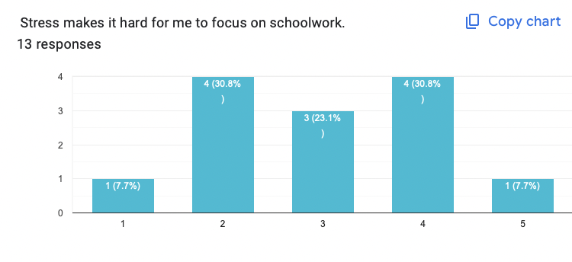
- Stress negatively impacts students’ ability to focus on schoolwork.
When asked whether stress makes it difficult to focus, most students selected ratings between 3 and 5, indicating that stress frequently interferes with academic concentration and productivity.
- Figure 2: Students prefer shorter lessons and simplified content when under stress.
Nearly half of respondents (46.2%) preferred lessons that are only 5–10 minutes long when they are overwhelmed, while the remaining students preferred traditional, longer lessons. However, across item responses, students consistently agreed that short lessons with quick check-ins help them stay engaged during stressful periods.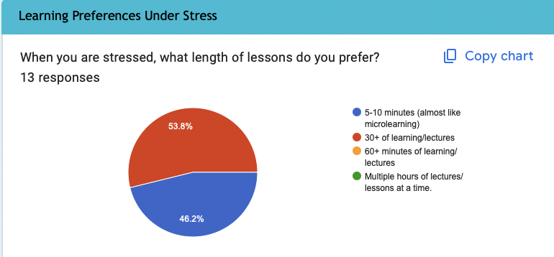
- Figure 3: Breaking content into smaller chunks increases students’ ability to keep up.
A majority of participants (over 80%) agreed that they would be more likely to stay on track if course material were divided into smaller, more manageable segments during stressful times.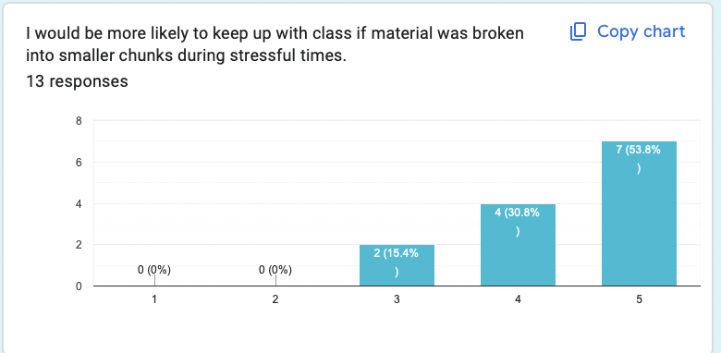
- Figure 4: Microlearning-style lessons were widely viewed as helpful for catching up.
When asked if short, TikTok-style or micro-video lessons would help them catch up after missing class due to stress, 61.5% said yes, while only one respondent said no. Several others chose “maybe,” indicating they would benefit but wanted more information.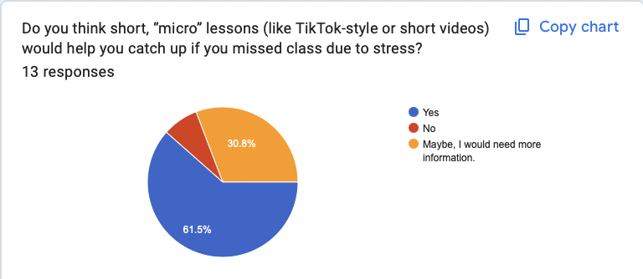
- Interview findings reinforced survey trends.
In one interview, a UT participant explained that when stress increases, motivation and attention decrease significantly. They reported difficulty sitting through long lectures and said short, direct lessons “match the way most college students naturally take in content now.” They also emphasized the need for flexibility and the ability to quickly review missed material.
In another interview, a UT participant stated that stress affects their retention and understanding of new information. The participant said that they set time limits when studying because if they didn’t, they “would be staring at a screen for hours on end.” They also stated that when they are stressed, shorter lessons with breaks in between help them study without overloading their brain.
Overall, the findings suggest that stress not only reduces students’ ability to focus, keep up with coursework, and retain lessons, but that short, modular microlearning lessons could meaningfully support engagement and help students recover when they fall behind or are feeling overwhelmed.

Limitations
One major limitation of our study was that we only had a sample size of 13 participants. Considering that the University of Tampa has just over 10,500 undergraduate students enrolled (as of Fall 2024), that is a low percentage of participation, which limits the results of the overall findings of the study (U.S. News & World Report, n.d.). The previous limitation ties into the fact that it was difficult to recruit students to participate in the study. The recruitment flyer was seen by many students, with only a few of them taking the time to complete the survey. Convenience was also a limitation for this survey. The participants of this study were chosen because of proximity, not because they were a total representation of all undergraduate students.

Ethical Considerations
Participants of this survey and interview were notified of the purpose of the research and the intended use of the data collected. We used undergraduate students from the University of Tampa who were age 18 and older. They were informed that their participation was voluntary and were able to stop the survey or interview at any time without repercussion. Recruitment flyers were distributed to student workers in the Office of Marketing and Communications and the Spartan Card Office, and students who frequented the Office of Access and Community Programs on the University of Tampa campus. Participation in the study provided minimal risk to participants and was unlikely to cause harm. The study was approved by the Institutional Research Board before any surveys or interviews were conducted.

Suggestions for Further Research
For future research, we suggest using a larger sample with students outside of the University of Tampa. By doing this, there will be more diverse answers and will, therefore, provide more accurate results to support the initial hypotheses. Another way that research can be improved is by having more time to recruit students to fill out the surveys. Being on a time crunch limited the amount of time that we had to conduct more thorough research. Finally, research can be improved by providing participants with an explanation of what microlearning is and what it entails. Students were responding to the survey with little to no information on what microlearning is, and by having more knowledge about it, the results could vary.

Implications/Conclusions
According to the data collected, the majority of participants have experienced heightened levels of stress within a month of completing the survey. Our research suggests that students can benefit from microlearning during times of increased stress. Microlearning lessons would help students stay on track with their course load while breaking lessons down into more manageable pieces. Simplified lessons would also help improve engagement among students during lectures.
Further research can be done in the future to confirm these results, but our research confirms our hypotheses that undergraduate students who experience higher levels of stress will demonstrate stronger academic retention when learning through microlearning and that students in lower-stress conditions will show less difference in retention across microlearning and traditional formats.

References
Bistricean, C., & Shea, M. (2021, November). Understanding Bereavement among College Students: Implications for Practice and Research. International Dialogues on Education: Past and Present, 8(1), 54-88. doi:10.53308/ide.v8i1.244
Doctor, J., Arguelles, E., Cinco, A., Dimayuga, D. A., & Maa, R. (2024, May). Grieving Process and Grief Coping Strategies of Selected Bereaved Students in a State College in Manila. Diversitas Journal, 9(1), 0495 – 0504. doi:10.48017/dj.v9i1_special.2979
Monib, W. K., Qazi, A., & Apong, R. A. (2024, December 20). Microlearning beyond
boundaries: A systematic review and a novel framework for improving learning outcomes. Heliyon. doi:10.1016/j.heliyon.2024.e41413
Moore, R. L., Hwang, W., & Moses, J. D. (2023, August). A systematic review of mobile-based microlearning in adult learner contexts. Educational Technology & Society, 137-146. doi:10.30191/ETS.202401_27(1).SP02
Sathiyaseelan, B., Mathew, J., & Nair, S. (2024). Microlearning and Learning Performance in Higher Education: A Post-Test Control Group Study. Journal of Learning for Development, 11(1), 1–14. https://doi.org/10.56059/jl4d.v11i1.752
Taylor, A., & Hung, W. (2022). The Effects of Microlearning: A Scoping Review.Educational Technology Research and Development, 70(2), 363-395. https://doi.org/10.1007/s11423-022-10084-1
Thillainadesan, J., Le Couteur, D. G., Haq, I., & Wilkinson, T. J. (2022). When I say … microlearning. Medical Education, 56(8), 791–792. https://doi.org/10.1111/medu.14848
U.S. News & World Report. (n.d.). University of Tampa Student Life - US News Best Colleges. University of Tampa Student Life. https://www.usnews.com/best-colleges/university-of-tampa-1538/student-life
Weppner, J., Conti, A., Locklear, T. & Mayer, R. (2024). Traditional Lecture Versus Procedural Video Randomized Trial. American Journal of Physical Medicine & Rehabilitation, 103 (6), 510-517. doi: 10.1097/PHM.0000000000002397.

Appendix A
Data Collection Materials

A.1 Informed Consent Form
This study will collect data using a brief online survey designed to measure college students’ stress levels, study habits, and opinions on how microlearning might support learning during stressful times. A survey was chosen because it allows data to be collected efficiently from multiple participants and provides both quantitative (ratings) and qualitative (open-ended) responses to understand trends and personal experiences.
Participants will include undergraduate students (age 18 or older) currently enrolled in U.S. colleges or universities. The survey will be administered one time through Google Forms and will take approximately 5–10 minutes to complete. Participants will complete the survey on their own devices at a time and place of their choosing. The survey will open with an informed consent statement and end with a thank-you message. No identifying information will be collected, and all responses will remain anonymous.
Title of Research
Microlearning in Higher Education to Support Distressed College Students
Researchers:
This study is being conducted by graduate students from the University of Tampa’s Instructional Design and Technology program, Asia Brown, Madeline Klessel, and Minkyoung Kim.

Purpose of the Study:
The purpose of this study is to explore how stress affects college students’ learning and whether short, focused lessons (known as microlearning) may help students stay engaged or catch up on material when under stress.
What You Will Do:
If you agree to participate, you will complete an online survey that asks about your background information, current stress level, and preferences for learning under stress. The survey will take about 5–10 minutes to complete.
Voluntary Participation:
Participation in this study is completely voluntary. You may choose not to take part, and you can exit the survey at any time before submitting. However, if you choose to continue, please note that all questions are required to ensure consistent and complete data for analysis.
Confidentiality:
All responses will remain anonymous. No names or identifying information will be collected, and your data will only be used for academic research purposes.
Benefits and Risks:
There are no known risks beyond everyday experiences. Your honest responses may help researchers and educators better understand how to support college students during stressful times through effective microlearning strategies.
Agreement:
By checking the box below, you confirm that you are 18 years of age or older and that you voluntarily agree to participate in this study.
☐ I agree to the statements above*

A.2 Survey Questions
- What year of college are you in?
- What is your major?
- On average, how many hours per week do you spend on schoolwork outside of class?
  - 0-5 hours
  - 5-10 hours
  - 10-15 hours
  - 15+ hours
- Over the past month, how stressed have you felt about school?
  - 1 (No stress)
  - 2
  - 3
  - 4
  - 5 (Extreme stress)
- What are your most significant sources of stress right now? Provide 2-3 examples.
- Stress makes it hard for me to focus on schoolwork.
  - 1 (Strongly disagree)
  - 2
  - 3
  - 4
  - 5 (Strongly Agree)
- Stress causes me to fall behind on readings, lectures, or assignments.
  - 1 (Strongly disagree)
  - 2
  - 3
  - 4
  - 5 (Strongly Agree)
- When you are stressed, what length of lessons do you prefer?
  - 5-10 minutes (Almost like microlearning)
  - 30+ minutes of learning/lectures
  - 60+ minutes of learning/lectures
  - Multiple hours of learning/lectures at a time
- Short lessons with quick check-in questions (like a mini quiz) help me stay engaged when I’m stressed.
  - 1 (Strongly disagree)
  - 2
  - 3
  - 4
  - 5 (Strongly Agree)
- I would be more likely to keep up with class if material was broken into smaller chunks during stressful times.
  - 1 (Strongly disagree)
  - 2
  - 3
  - 4
  - 5 (Strongly Agree)
- Do you think short, “micro” lessons (like TikTok-style or short videos) would help you catch up if you missed class due to stress?
  - Yes
  - No
  - Maybe, I would need more information.

A.3 Interview Questions/Protocol
Protocol
- Introduction (2–3 minutes)
- Welcome participant and thank them for their time.
- Review the study purpose, confidentiality, and consent information.
Statement: Please confirm you are over 18.
- Confirm permission to record via Zoom.
  - If no to video, ask about audio.
    - If no to both, take notes.
- Core Questions for interview (10-20 minutes)

These questions focus on the primary research objectives. Examples: (Follow-up prompts: “Can you tell me more about that?” “What led you to that decision?” “How did that impact the outcome?”)

Interview #1: Focus on stress and academic experiences
- Can you describe a time recently when stress made it harder for you to keep up with schoolwork?
- What kinds of assignments or formats are the hardest to manage when you’re stressed?
- Do you feel like stress affects how much you actually remember from your classes? How so?
- What helps you the most when you’re trying to stay on top of schoolwork during stressful times?
Interview #2: Focus is on microlearning and support strategies
- When you’re stressed, what kind of learning activities feel most manageable to you?
- How do you feel about shorter lessons (like small videos, quick readings, or mini quizzes) compared to longer lectures or chapters?
- Could microlearning help reduce stress or make learning feel less overwhelming? Why or why not?
- If you could design one change to how your professors deliver material during stressful times, what would it be?

A.4 Debriefing Statement
Thank you for participating in our study. The purpose of this research is to explore how microlearning—short, focused lessons—might help college students manage academic responsibilities during stressful times. We are interested in understanding whether this learning approach can improve retention, motivation, and overall academic performance for students experiencing higher levels of stress.
During the study, you were asked questions about your experiences with stress, your learning preferences, and your thoughts about shorter learning formats. Your responses will help us better understand how to design instructional materials that are both effective and supportive for students facing academic or emotional challenges.
All information collected in this study will remain confidential. Individual responses will not be shared, and no identifying information will appear in our report or presentation. If you wish to withdraw your data from the study, please contact the researchers at the email addresses below within two weeks.
If answering questions about stress or academic pressure brought up any discomfort, we encourage you to reach out for support. You may contact your college’s student counseling services or mental health support center for free and confidential help.
If you have any questions or would like to learn more about the study’s results, please contact:
Asia Brown – adbrown@ut.edu
Madeline Klessel – madeline.klessel@spartans.ut.edu
Minkyoung Kim – mkim@ut.edu
Thank you again for your time and valuable input. Your participation contributes to research that aims to improve educational experiences for students navigating stress and academic demands. This research project has been approved by the Institutional Review Board for the Protection of Human Subjects of the University of Tampa. For more information concerning the University of Tampa’s Institutional Review Board (IRB), you may contact the IRB at irb@ut.edu.

Appendix B

B.1 Survey Results

Timestamp | Column 1 |  | What year of college are you in? |  | What is your major? | On average, how many hours per week do you spend on schoolwork outside of class?
11/5/2025 10:08:32 | I have read the information above and agree to participate in this study. |  | Senior |  | Communications | 0-5 hours
11/6/2025 13:46:26 | I have read the information above and agree to participate in this study. |  | Sophomore |  | Economics | 0-5 hours
11/10/2025 14:56:51 | I have read the information above and agree to participate in this study. |  | Senior |  | Communication and Media Studies | 10-15 hours
11/10/2025 14:57:22 | I have read the information above and agree to participate in this study. |  | First year |  | Marketing | 5-10 hours
11/10/2025 14:57:32 | I have read the information above and agree to participate in this study. |  | Sophomore |  | Advertising and PR | 0-5 hours
11/10/2025 15:00:44 | I have read the information above and agree to participate in this study. |  | Senior |  | Advertising and Public Relations | 0-5 hours
11/10/2025 15:05:40 | I have read the information above and agree to participate in this study. |  | First |  | Marketing & Film | 0-5 hours
11/11/2025 15:20:05 | I have read the information above and agree to participate in this study. |  | Senior |  | Advertising and Public Relations | 10-15 hours
11/13/2025 14:07:34 | I have read the information above and agree to participate in this study. |  | sykes college of business |  | finance | 5-10 hours
11/14/2025 10:00:56 | I have read the information above and agree to participate in this study. |  | 2nd |  | Graphic Design | 5-10 hours
11/14/2025 15:50:40 | I have read the information above and agree to participate in this study. |  | Senior |  | Biology | 10-15 hours
11/16/2025 14:55:09 | I have read the information above and agree to participate in this study. |  | Sophomore (2nd) |  | Cybersecurity | 5-10 hours
11/17/2025 14:54:36 | I have read the information above and agree to participate in this study. |  | Senior |  | sports management | 5-10 hours
Over the past month, how stressed have you felt about school? |  | What are your most significant sources of stress right now? Provide 2-3 examples. |  | Stress makes it hard for me to focus on schoolwork. |  |  | Stress causes me to fall behind on readings, lectures, or assignments.
1 |  | Project |  | 1 |  |  | 1
2 |  | Work, homework, exams. |  | 2 |  |  | 3
5 |  | Graduation, Work, Thesis |  | 4 |  |  | 3
3 |  | speech course and group projects across classes |  | 4 |  |  | 3
2 |  | Mental health and work |  | 3 |  |  | 2
2 |  | Family |  | 3 |  |  | 2
4 |  | My math class and bio class |  | 4 |  |  | 4
5 |  | Registering for classes |  | 2 |  |  | 2
5 |  | homework and exams |  | 5 |  |  | 5
4 |  | ⁸Homework and job |  | 3 |  |  | 2
3 |  | Finals and grades |  | 2 |  |  | 1
3 |  | Keeping up with work obligations; applying to different internships; keeping up with people and maintaining my network. |  | 2 |  |  | 3
3 |  | Making sure assignments are turned in on time. Making sure I practice for presentations because they stress me out. |  | 4 |  |  | 3
When you are stressed, what length of lessons do you prefer? |  | Short lessons with quick check-in questions (like a mini quiz) help me stay engaged when I’m stressed. |  | I would be more likely to keep up with class if material was broken into smaller chunks during stressful times. |  |  | Do you think short, “micro” lessons (like TikTok-style or short videos) would help you catch up if you missed class due to stress?
5-10 minutes (almost like microlearning) |  | 5 |  | 5 |  |  | Yes
30+ of learning/lectures |  | 3 |  | 4 |  |  | Yes
30+ of learning/lectures |  | 3 |  | 4 |  |  | Yes
5-10 minutes (almost like microlearning) |  | 4 |  | 3 |  |  | Maybe, I would need more information.
5-10 minutes (almost like microlearning) |  | 4 |  | 4 |  |  | No
30+ of learning/lectures |  | 3 |  | 3 |  |  | Maybe, I would need more information.
30+ of learning/lectures |  | 3 |  | 4 |  |  | Yes
5-10 minutes (almost like microlearning) |  | 4 |  | 5 |  |  | Yes
5-10 minutes (almost like microlearning) |  | 3 |  | 5 |  |  | Yes
30+ of learning/lectures |  | 4 |  | 5 |  |  | Maybe, I would need more information.
5-10 minutes (almost like microlearning) |  | 5 |  | 5 |  |  | Yes
30+ of learning/lectures |  | 4 |  | 5 |  |  | Maybe, I would need more information.
30+ of learning/lectures |  | 5 |  | 5 |  |  | Yes

B.2 Interview Results
The following passages are summaries of two interviews conducted during the research.

Interview #1
The person that was selected for the first interview is a senior undergraduate student at the University of Tampa who is majoring in Biology. She is a full-time student with two on-campus jobs. She was selected for this interview because her major is a more strenuous major that requires a lot of studying and reading outside of the classroom and lab.
She stated that one of her most recent stressors was having multiple exams back-to-back, which made it difficult for her to set aside time to properly study for all of the exams. She believed that professors not thoroughly explaining some of the topics in class made it more difficult for her to do assignments and caused her to use outside resources to get a better understanding. She also noted that sometimes stress makes it difficult to retain and understand some of her lessons.
Overall, she believed that breaking lessons into smaller chunks allowed her to focus better and stay engaged because she is able to take brain breaks between her studies.

Interview #2
I chose to interview a junior undergraduate student at the University of Tampa who is currently majoring in Communications. He is a full-time student who balances academic responsibilities alongside work and personal commitments. I selected him as a participant because his experiences closely align with the focus of my study, understanding how college students experiencing higher levels of stress engage with instructional materials.
Through the interview, I learned that he manages a demanding schedule, often juggling coursework, employment, and social obligations. He explained that this balance can become overwhelming, and as a result, he frequently experiences increased stress throughout the semester. When discussing instructional preferences, he expressed that he learns best through shorter, focused lessons that get directly to the point. Because of this, the concept of microlearning strongly appealed to him.
He shared that traditional, lengthy lessons sometimes make it difficult for him to stay engaged, especially when he is already feeling stressed or pressed for time. In contrast, he believed that microlearning could help him stay organized and retain information by breaking content into manageable pieces. Overall, he showed genuine interest in learning more about microlearning and felt that this type of instructional design would support his academic success, reduce stress, and help him balance his responsibilities more effectively.

